

|  |  |  |  |  |  |  |
| --- | --- | --- | --- | --- | --- | --- |
| Date : 27/04/2022 | | | | | | |
|  | **CSLR62**  App Development Laboratory  **Record File** | | | | |  |
|  |  | | | | |  |
|  | | |  |  | | |
|  | | | Roll no.: 106119100Name: Rajneesh PandeySection: CSE-B |  | | |
|  | |  | | |  | |

**Index**

|  |  |  |
| --- | --- | --- |
| **Experiment No.** | **Date** | **Page No.** |
|  |  |  |
| Experiment 1 | 02/02/2022 | 03 |
| Experiment 2 | 02/02/2022 | 06 |
| Experiment 3 | 13/02/2022 | 10 |
| Experiment 4 | 20/02/2022 | 12 |
| Experiment 5 | 06/03/2022 | 20 |
| Experiment 6 | 16/03/2022 | 21 |
| Experiment 7 | 20/04/2022 | 28 |
| Experiment 8 | 20/04/2022 | 30 |
| Experiment 9 | 20/04/2022 | 32 |
| Experiment 10 | 20/04/2022 | 36 |
| Experiment 11 | 20/04/2022 | 37 |

Date : 02/02/2022  **Lab 1**

**Problem statement**

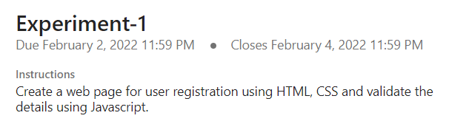

**Tools/Programming Languages Used**

HTML, CSS, JavaScript

**Code Link**

<https://drive.google.com/drive/folders/1UDCQhPfc_Mv-1wWJff0iQNBgxh_kvurQ?usp=sharing>

**Screenshots of Application**

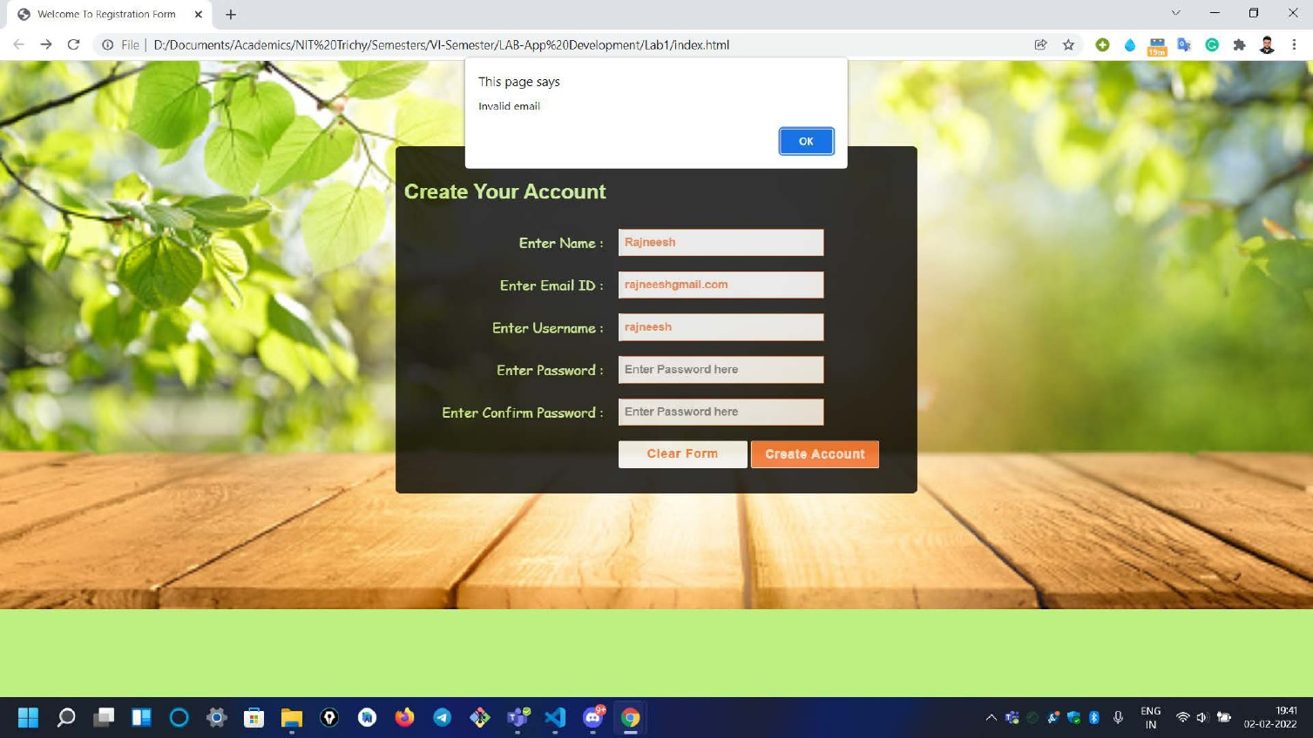

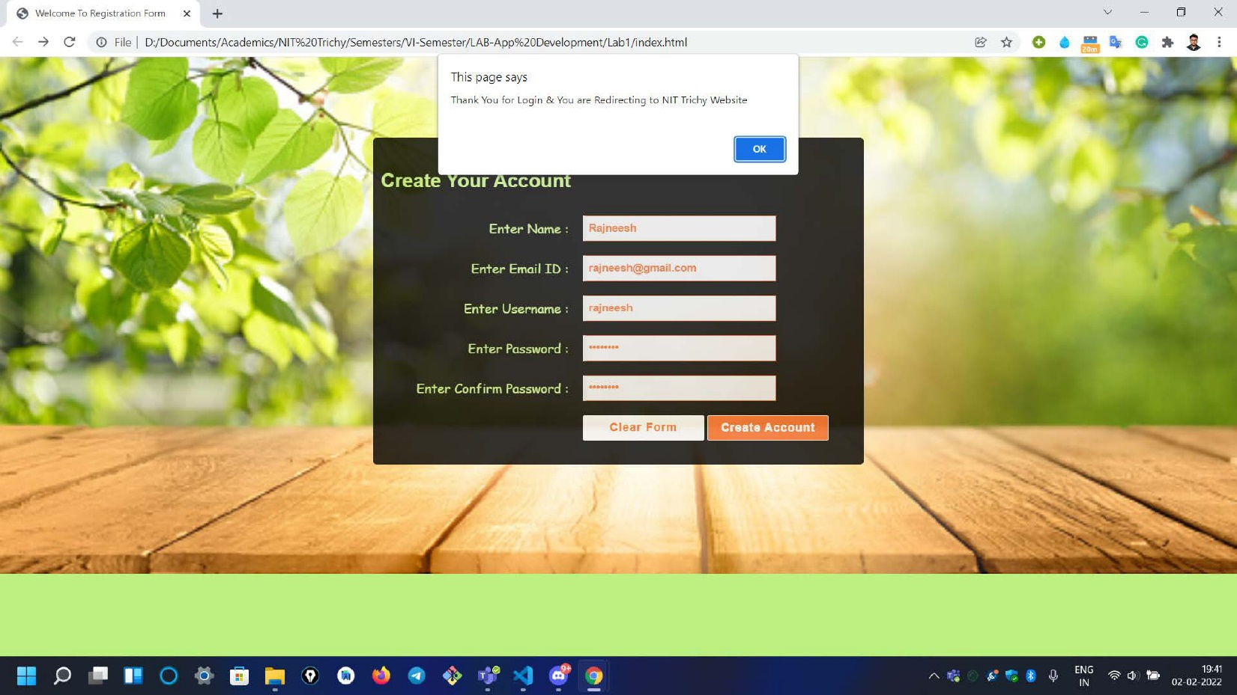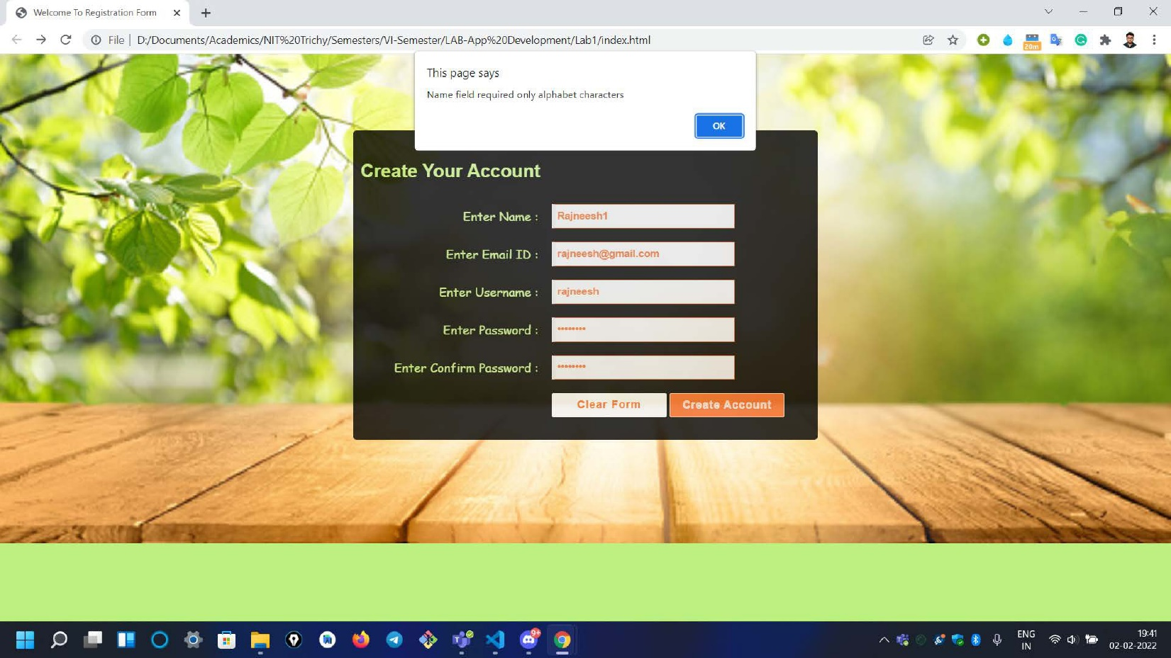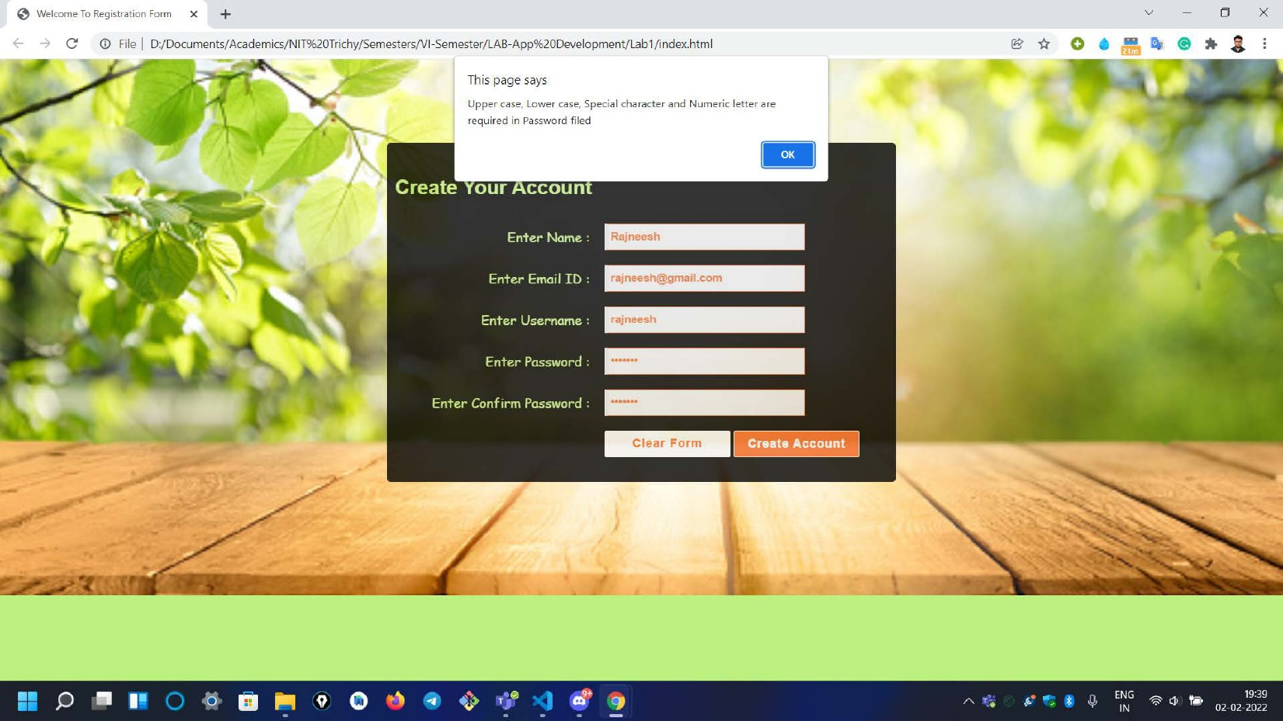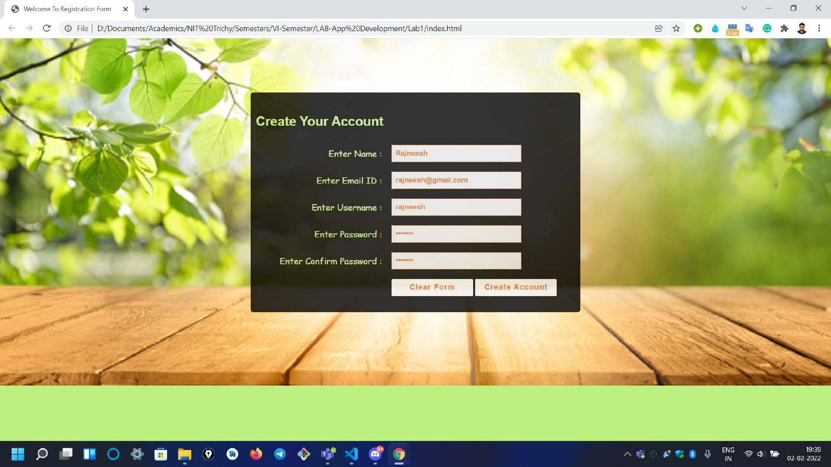

Date : 02/02/2022  **Lab 2**

**Problem statement**

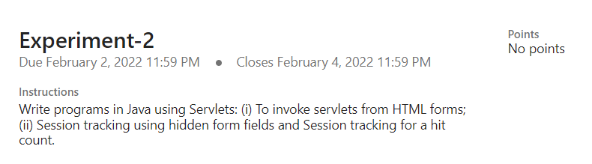

**Tools/Programming Languages Used**

Java , Servlets, HTML

**Code Link**

<https://drive.google.com/drive/folders/1JX6OnbGS4ipC1GDTUtRWQ0FcU0dtfdh3?usp=sharing>

**Screenshots of Application**

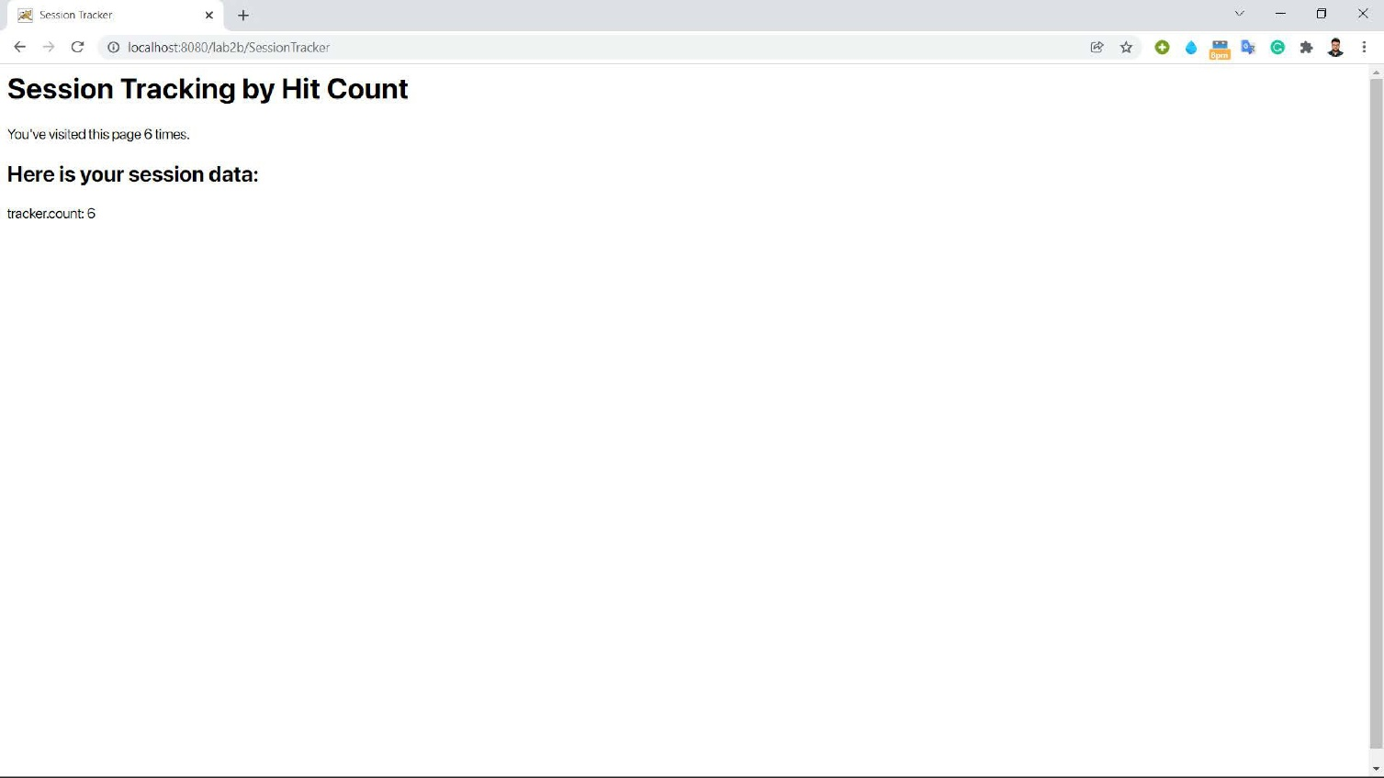

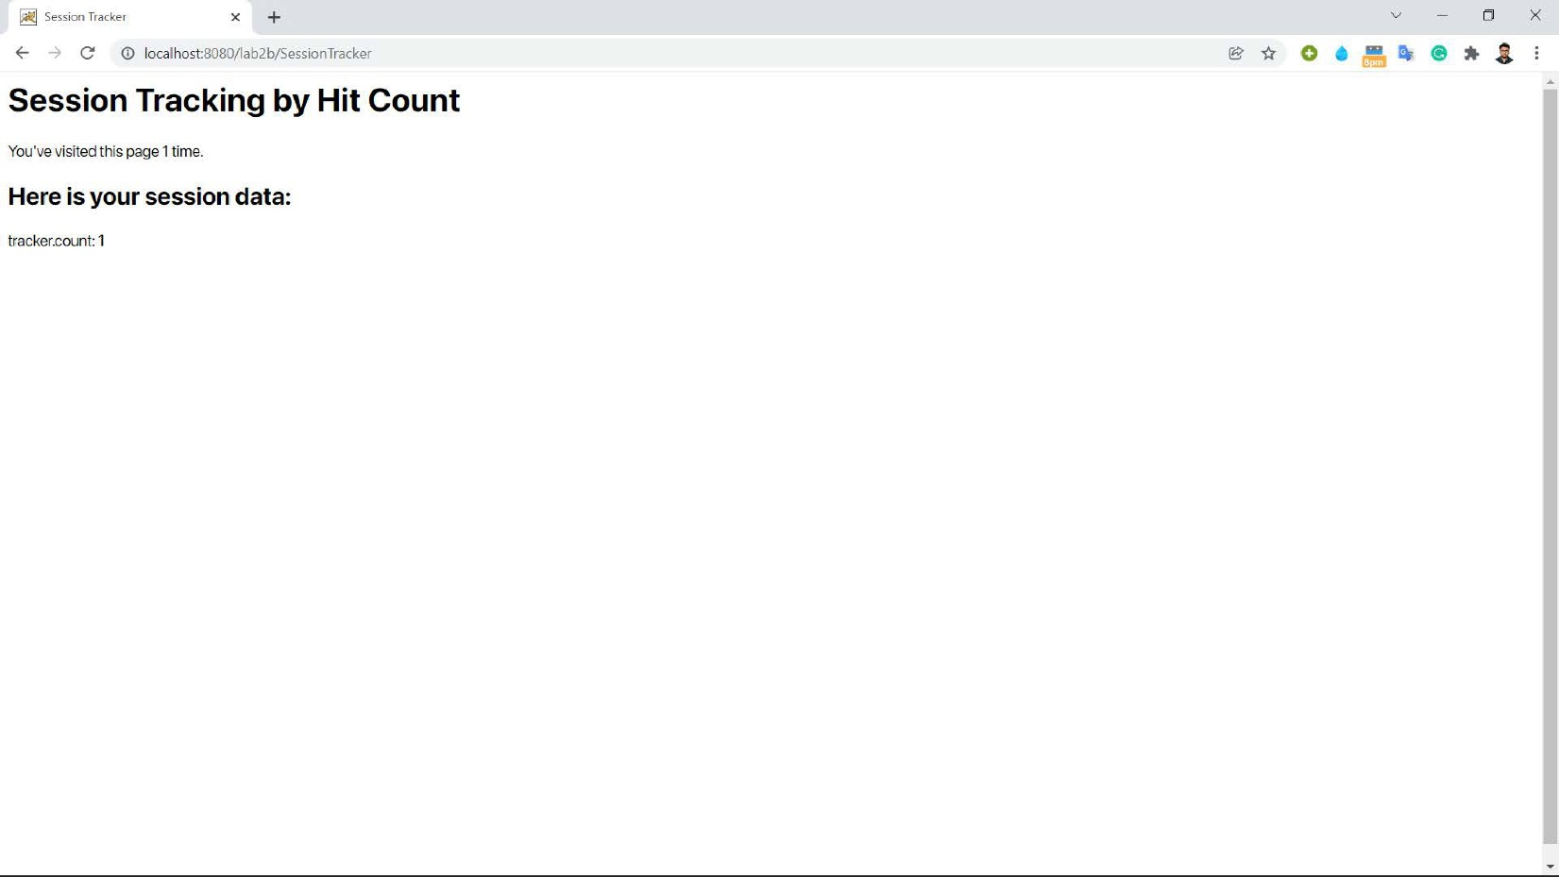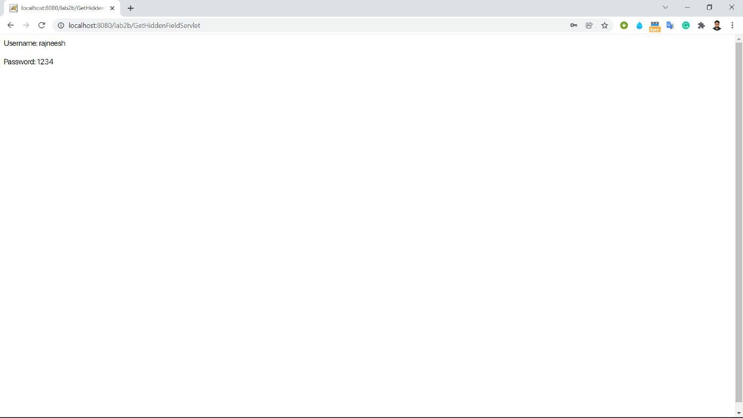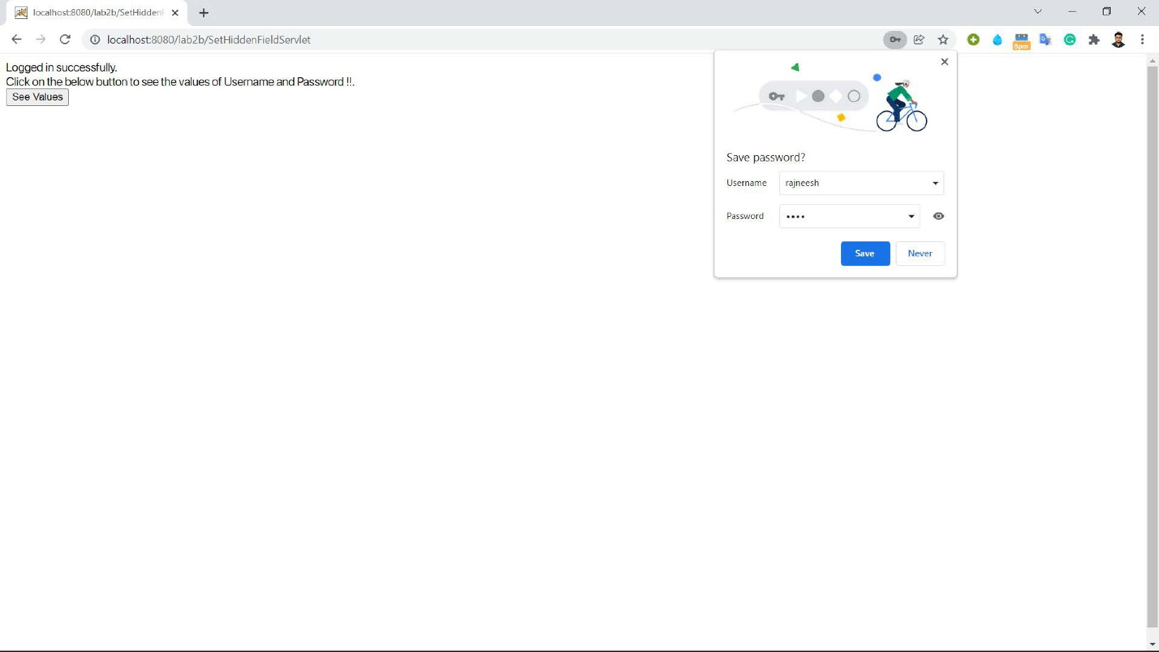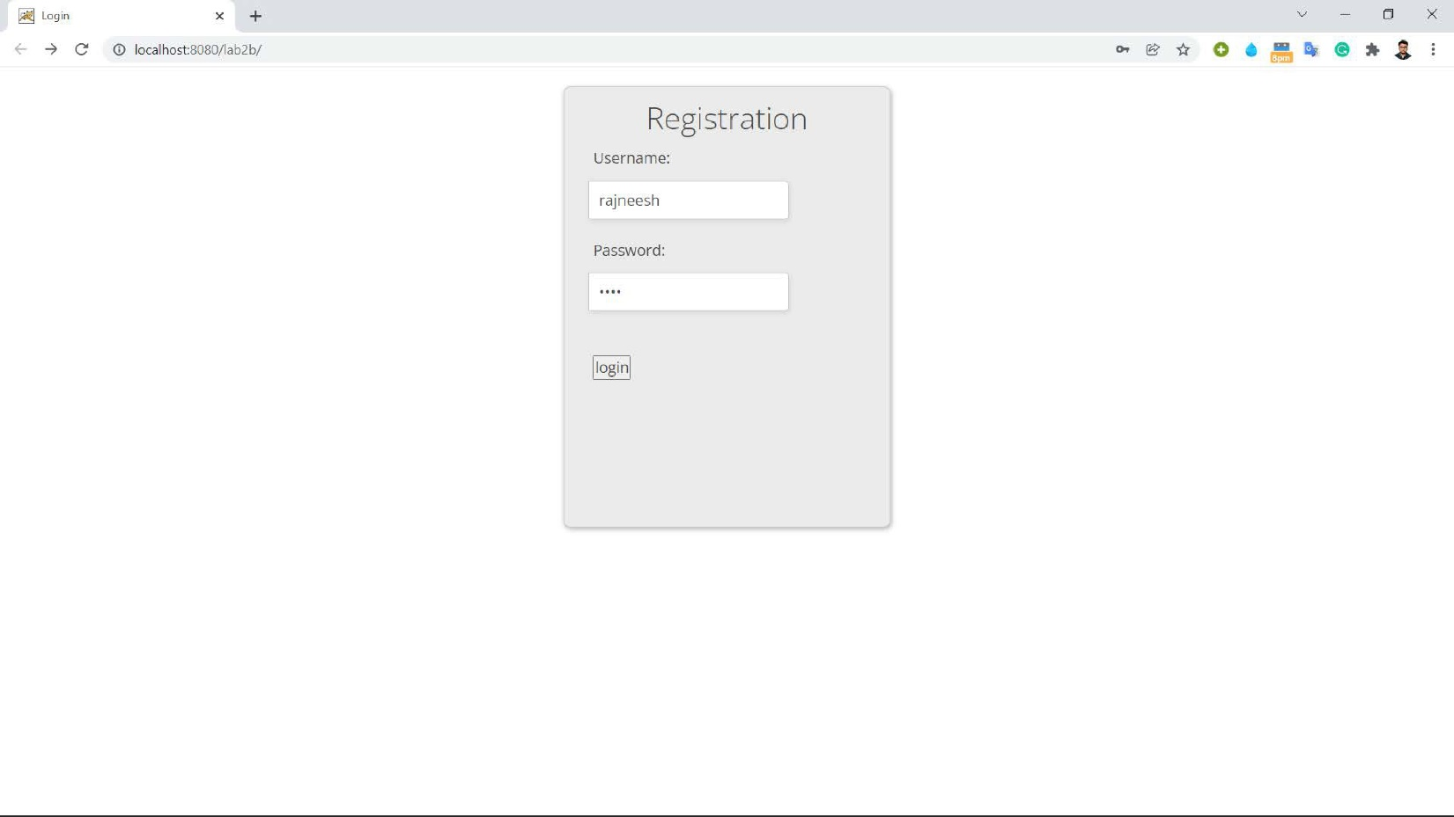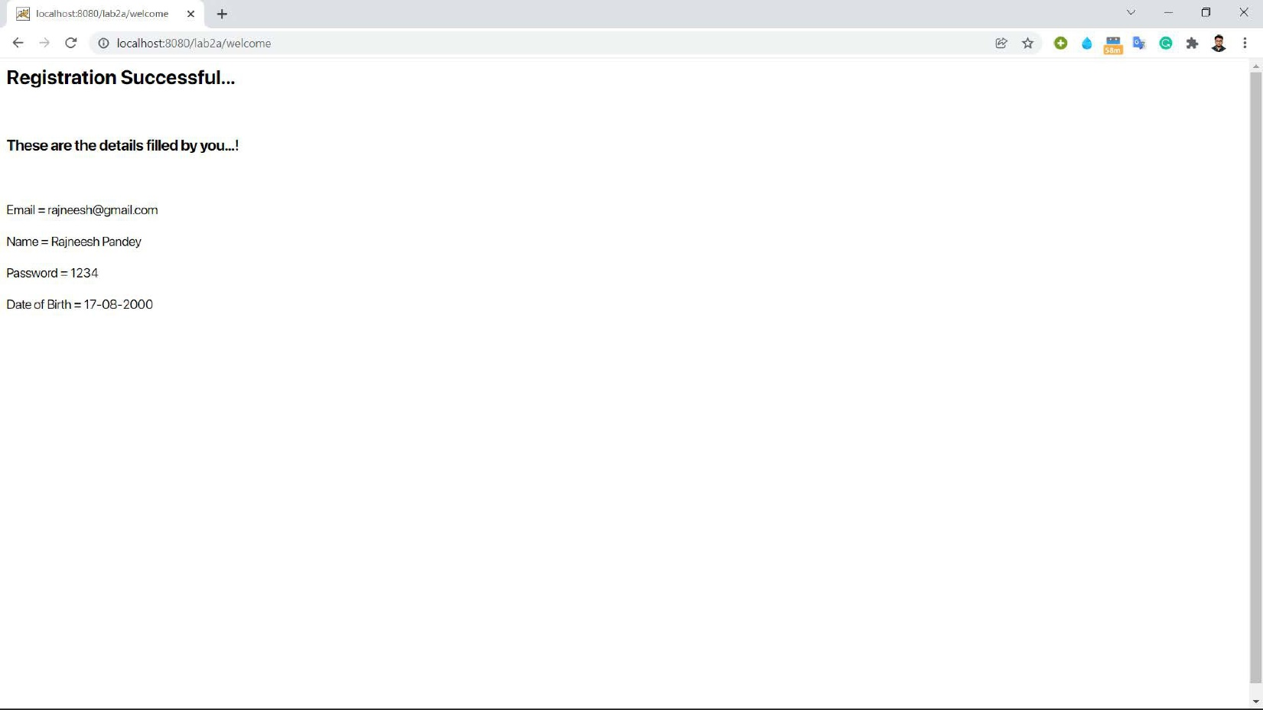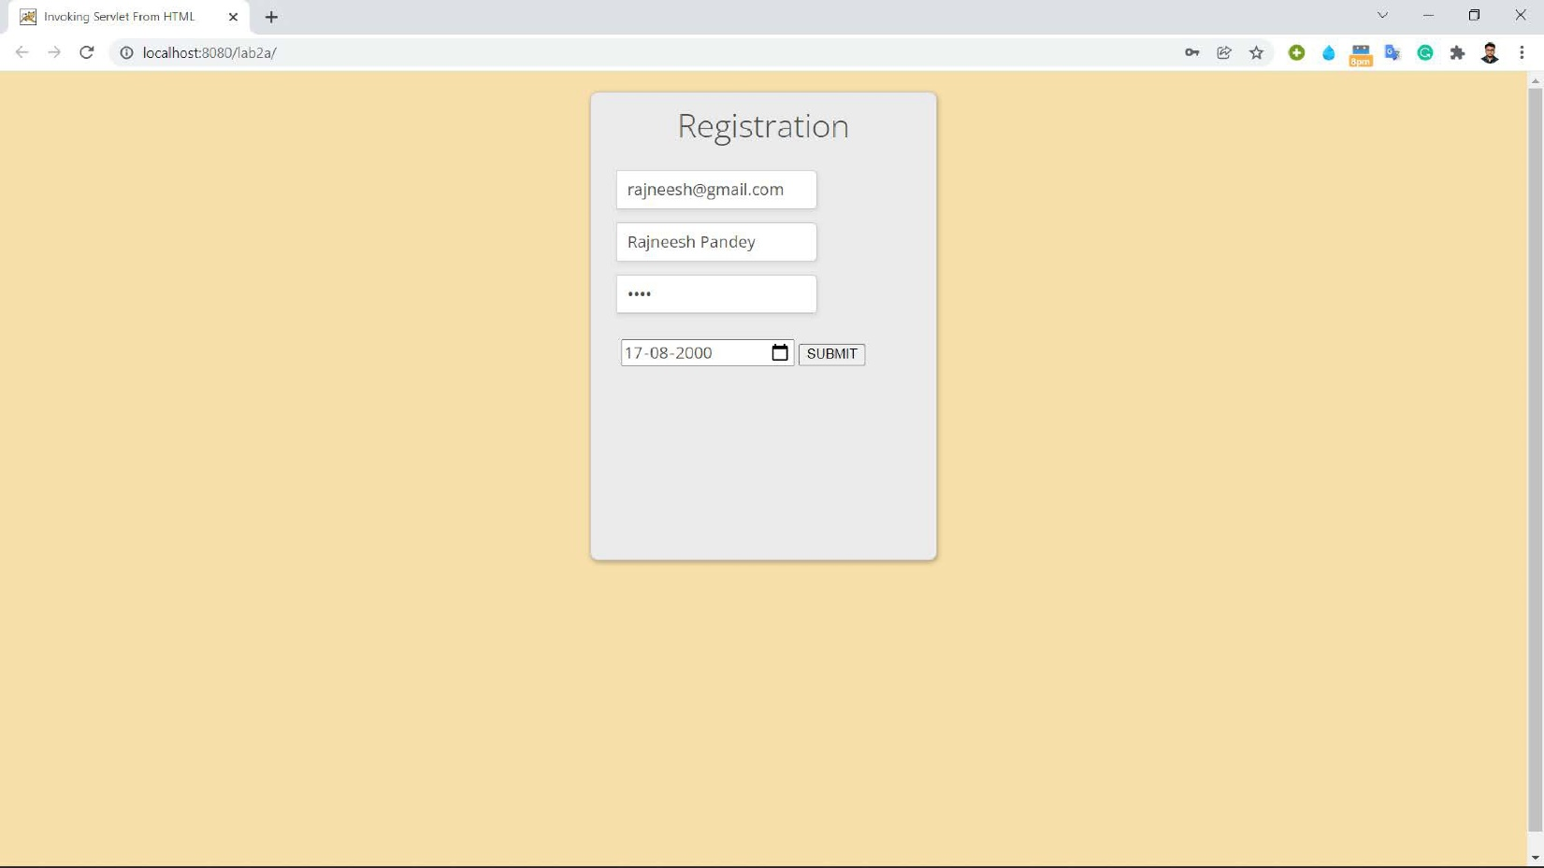

Date : 13/02/2022  **Lab 3**

**Problem statement**

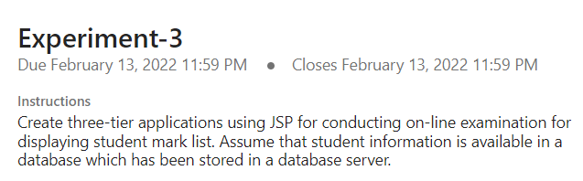

**Tools/Programming Languages Used**

Java , JSP , Microsoft Access (Databases)

**Code Link**

<https://drive.google.com/drive/folders/1J5onahJVhhw1Q9_5vVHU9Zp7BU8DD7aa?usp=sharing>

**Screenshots of Application**

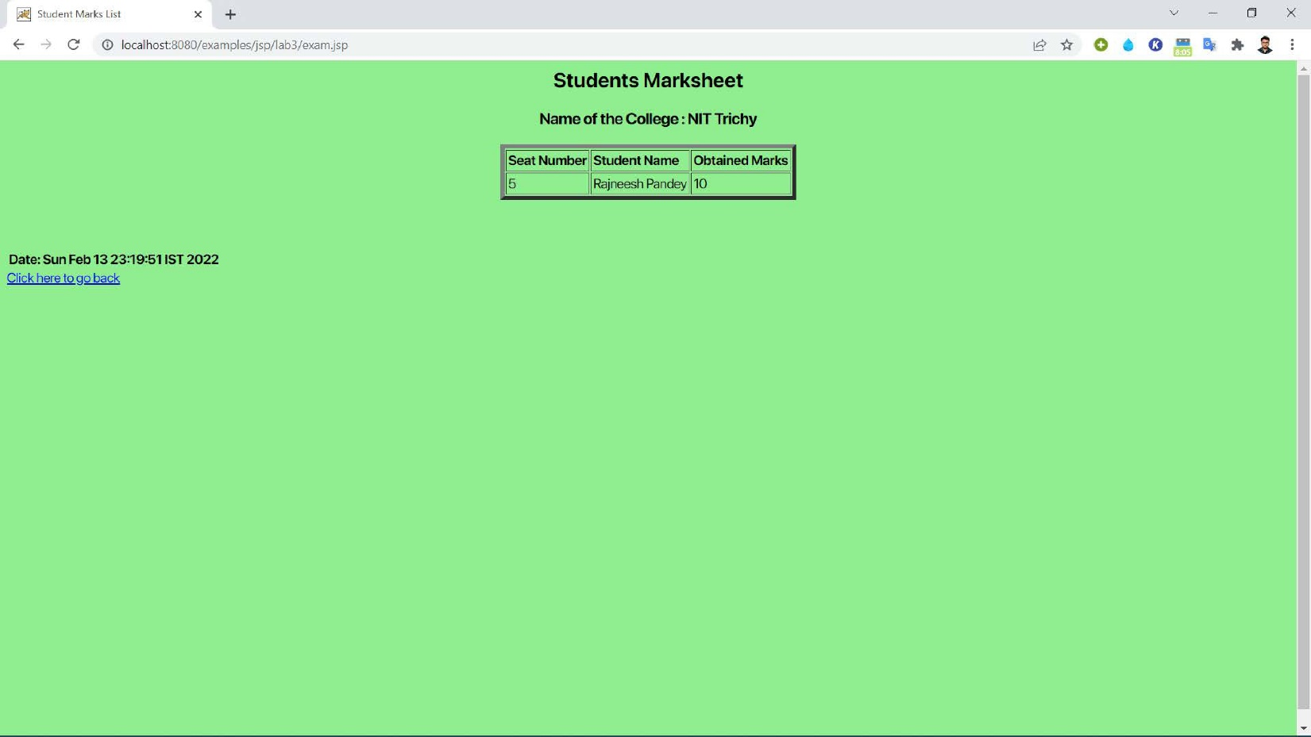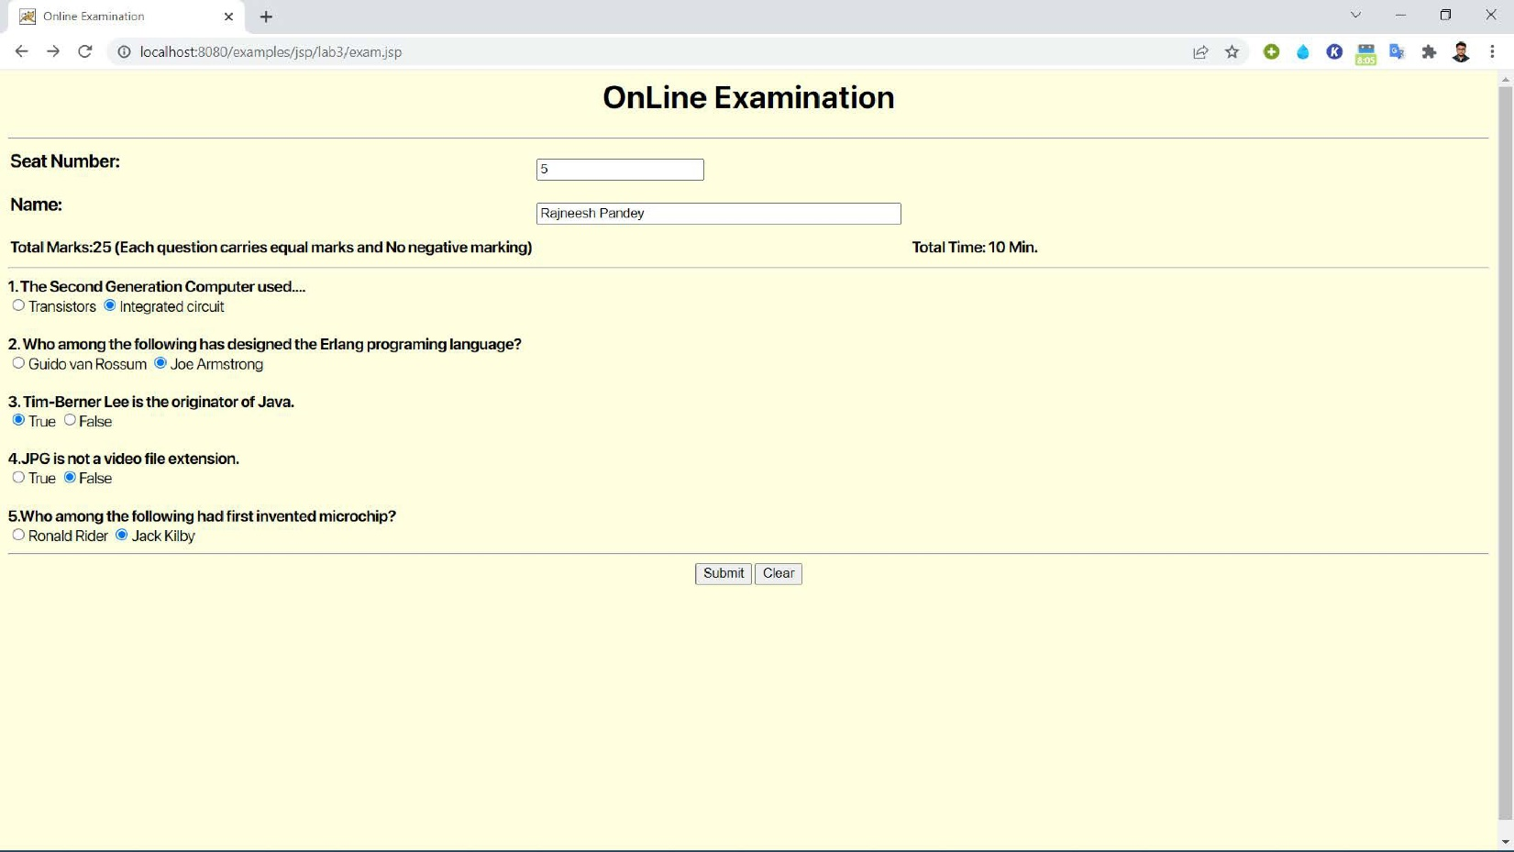

Date : 20/02/2022  **Lab 4**

**Problem statement**

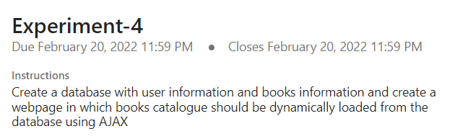

**Tools/Programming Languages Used**

AJAX, Microsoft Access (Databases)

**Code Link**

<https://drive.google.com/drive/folders/1ICCw0wSp304RFoQkppLxU5HAhDU6sYC3?usp=sharing>

**Screenshots of Application**

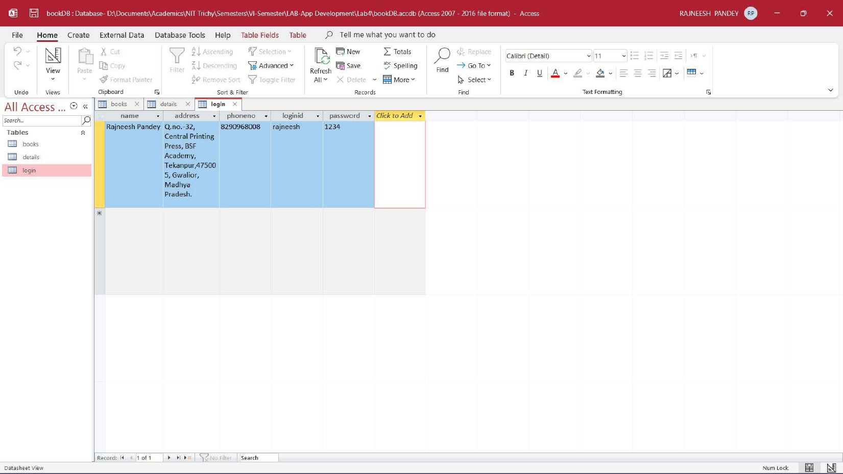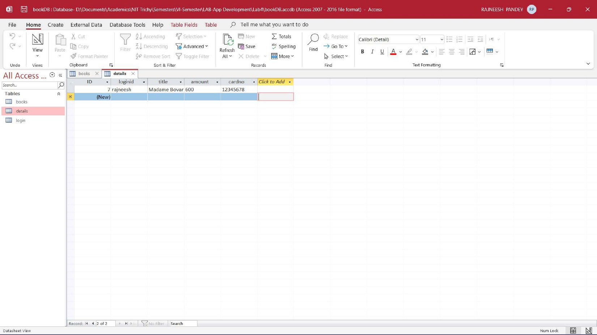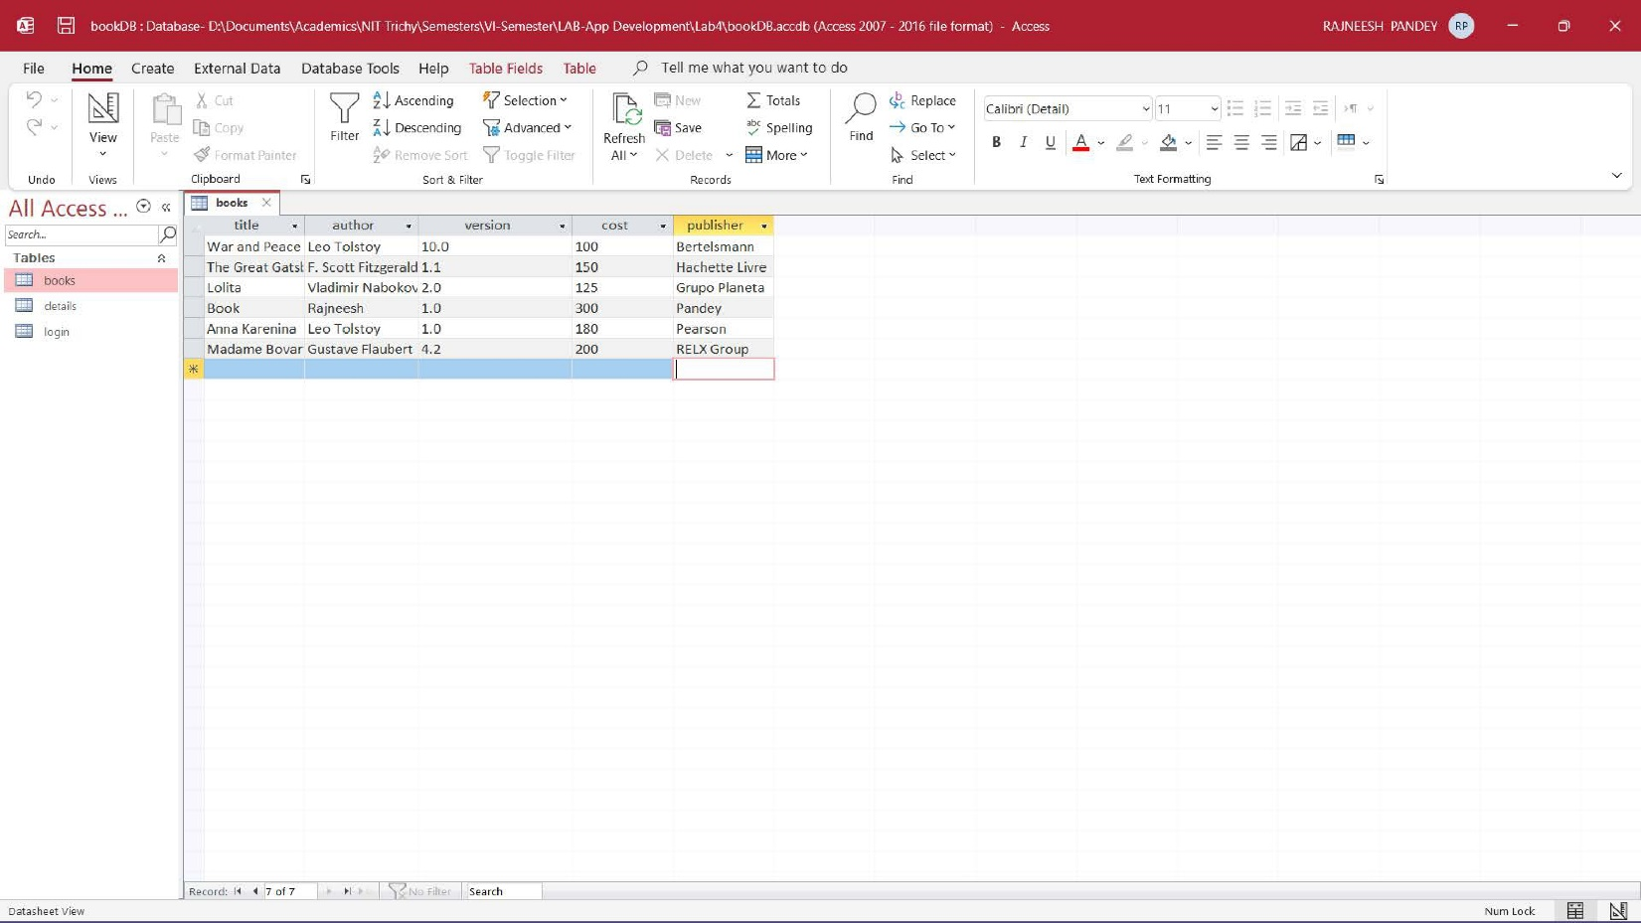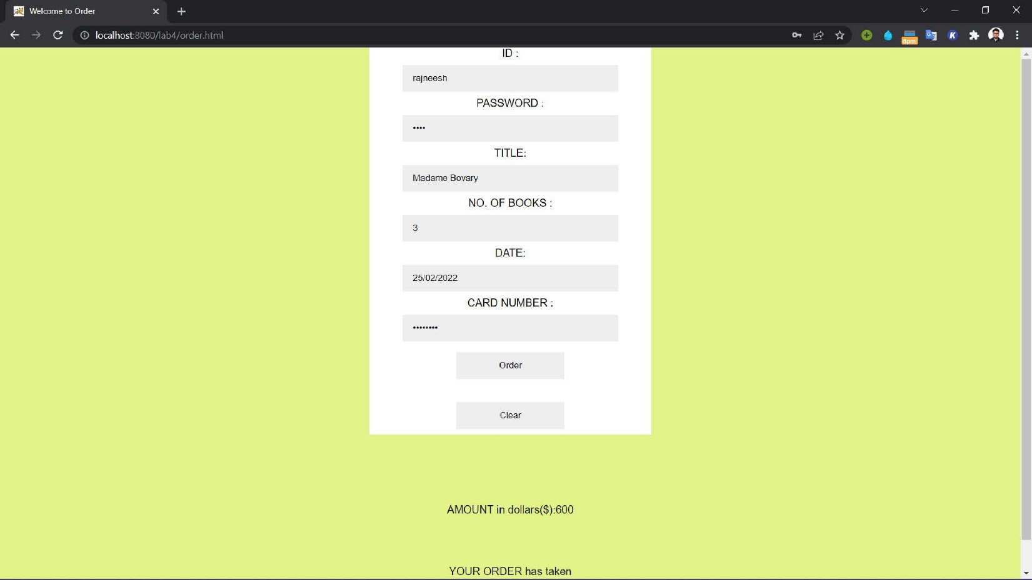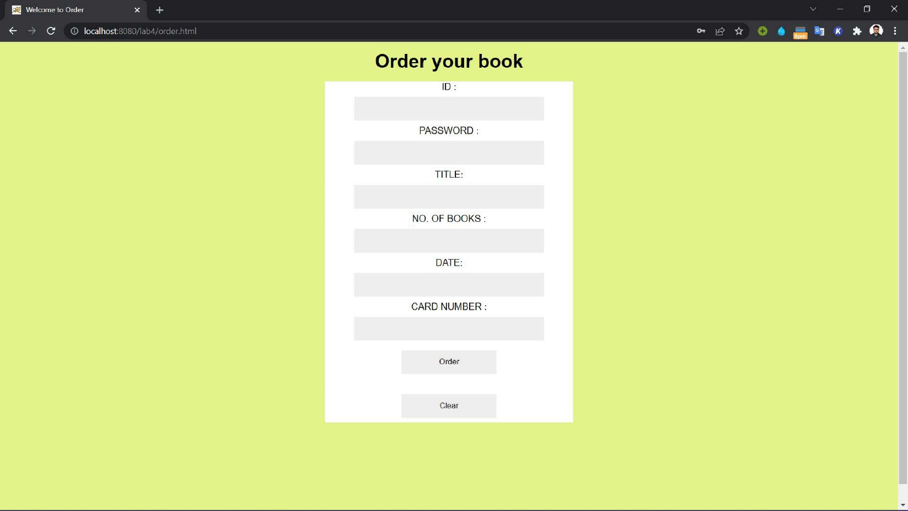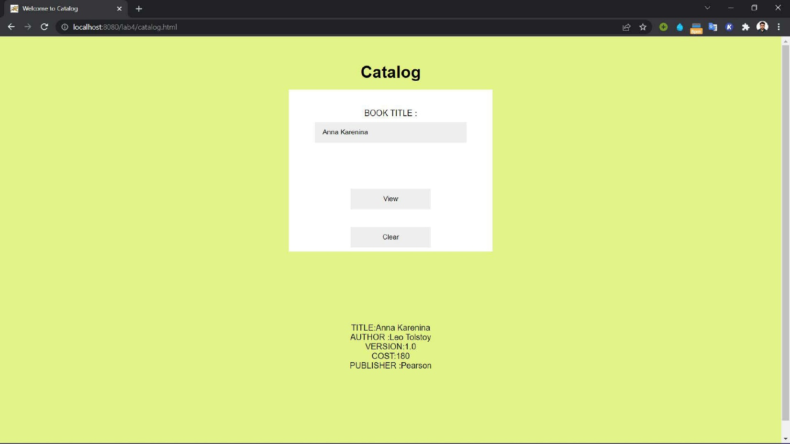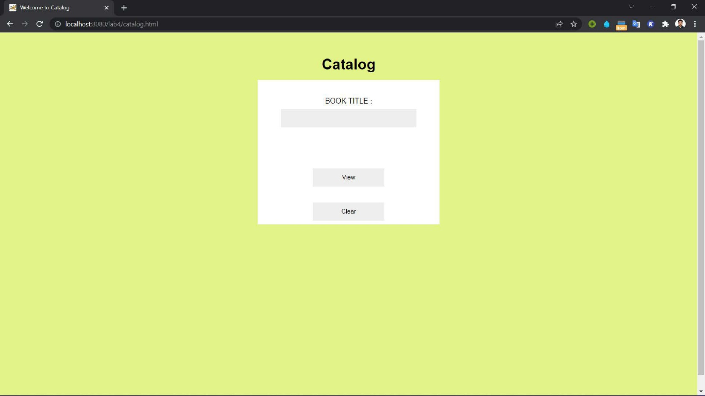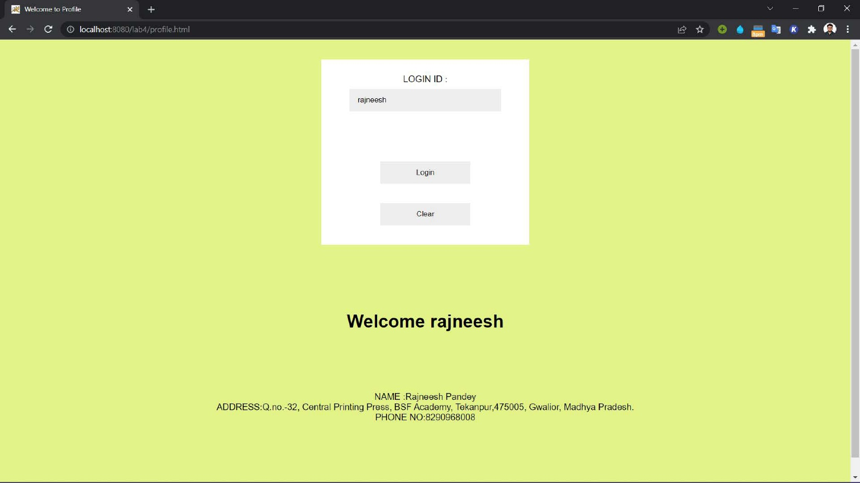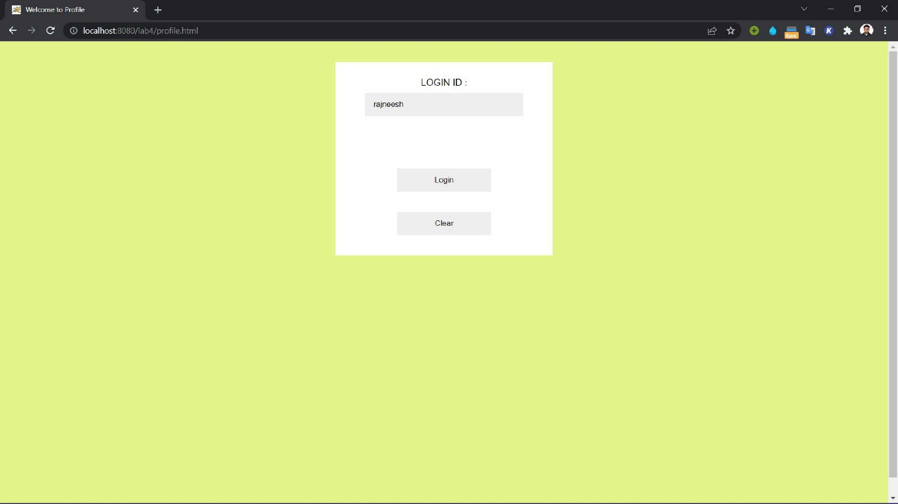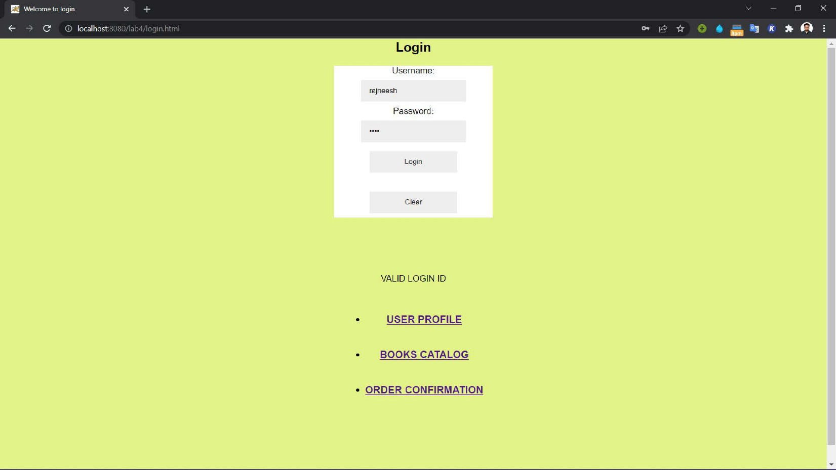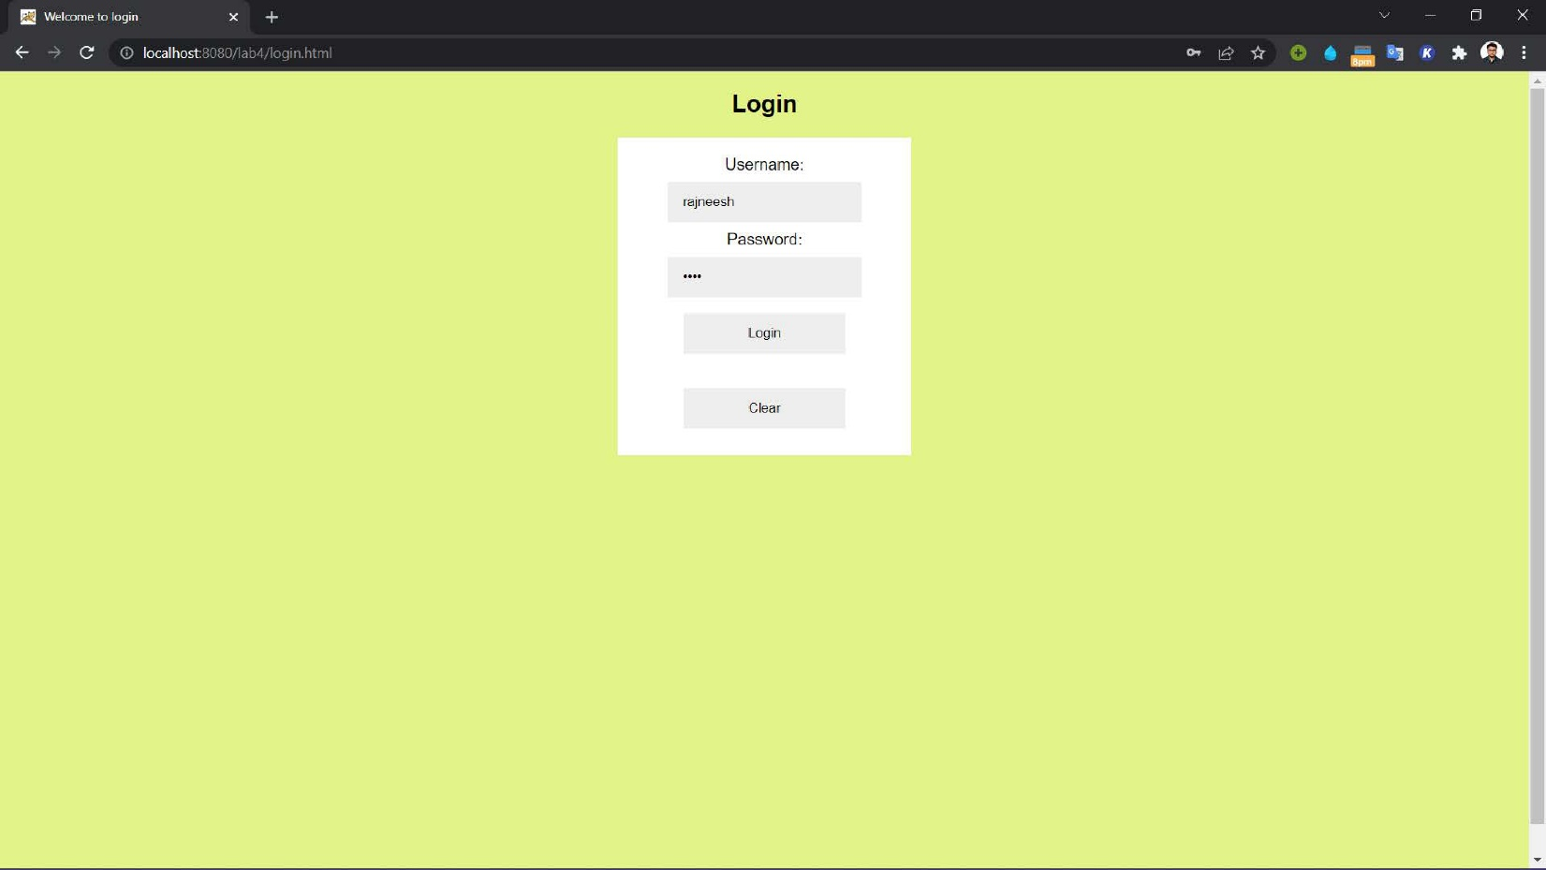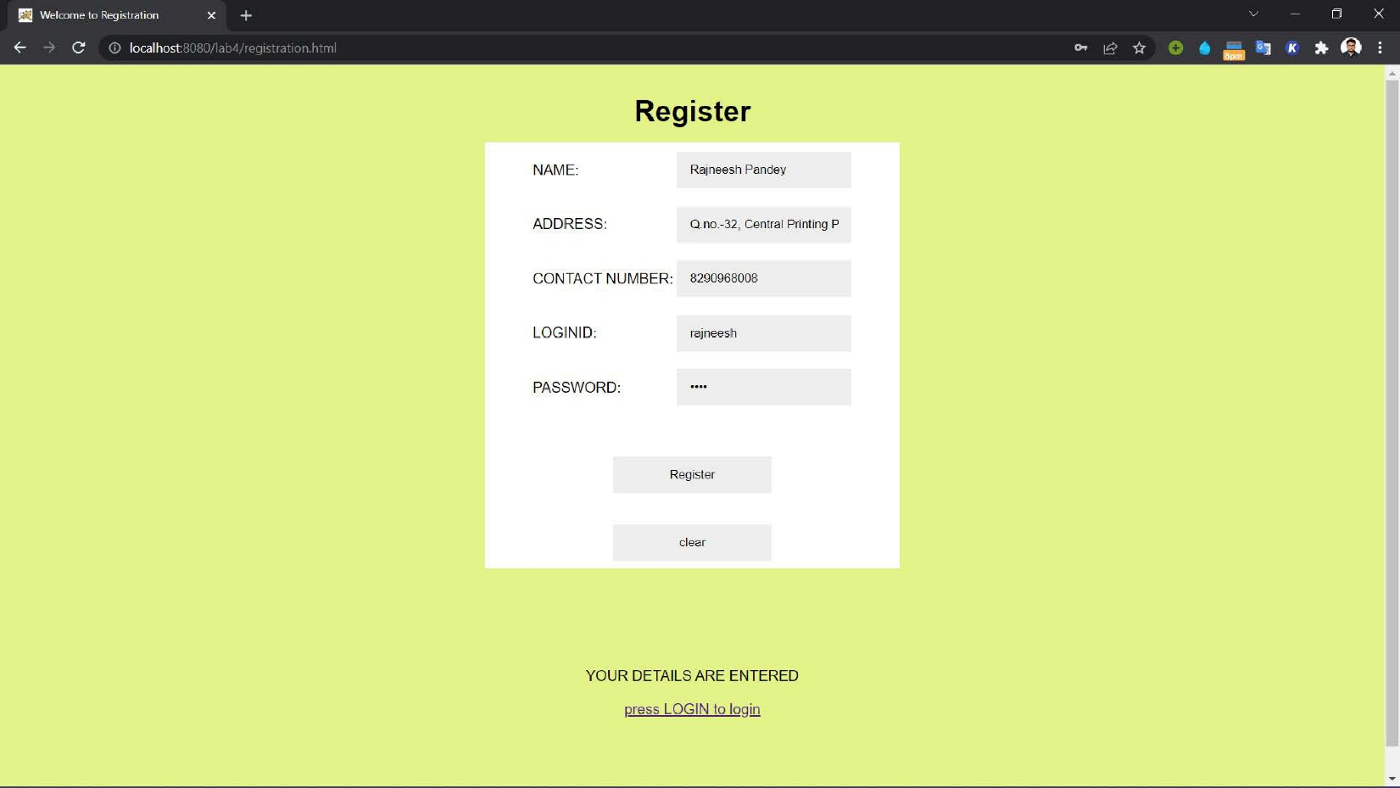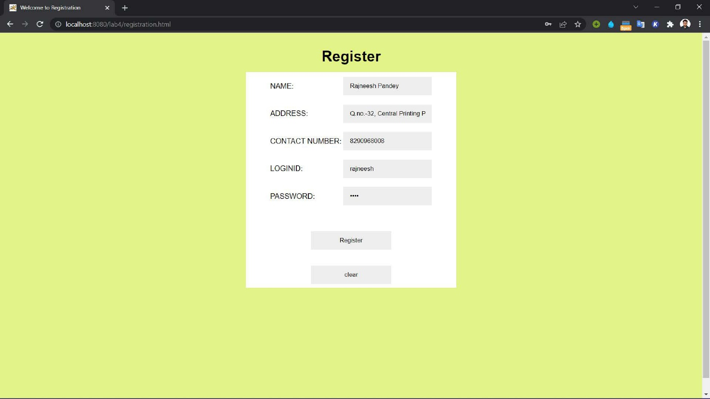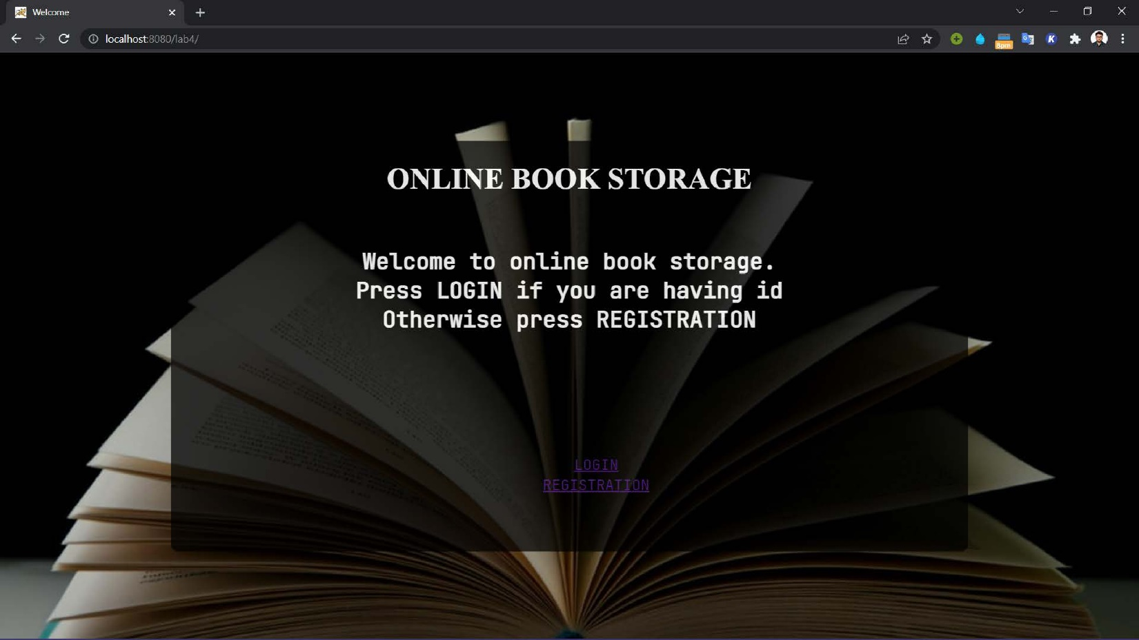

Date : 06/03/2022  **Lab 5**

**Problem statement**

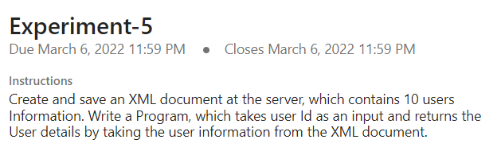

**Tools/Programming Languages Used**

XML, HTML, python server

**Code Link**

<https://drive.google.com/drive/folders/1ZvvUFqbXw4aUJvxS-2RriNgqNQd4G2Ls?usp=sharing>

**Screenshots of Application**

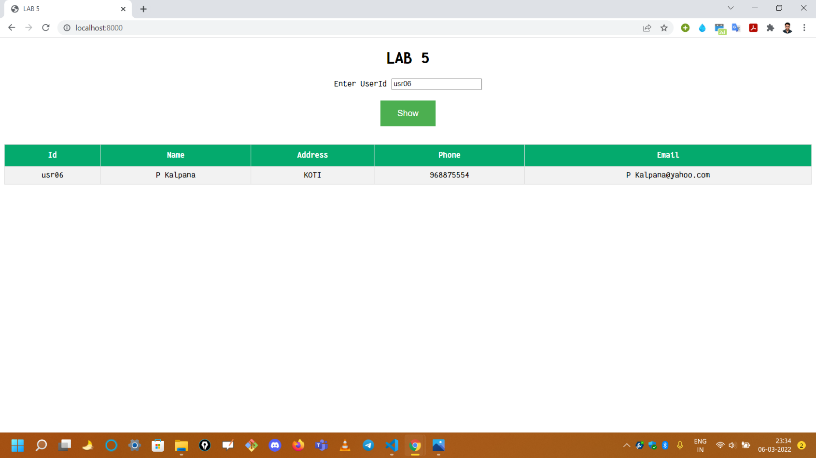

Date : 16/03/2022  **Lab 6**

**Problem statement**

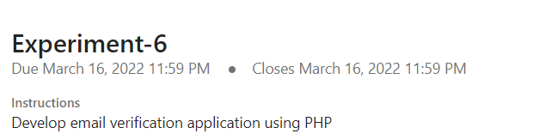

**Tools/Programming Languages Used**

PHP, MySQL, Xampp, phpMailer, CSS

**Code Link**

<https://drive.google.com/drive/folders/1R-zW7sRFcYykbSq8cKiDAi3HIX-OlsVH?usp=sharing>

**Screenshots of Application**

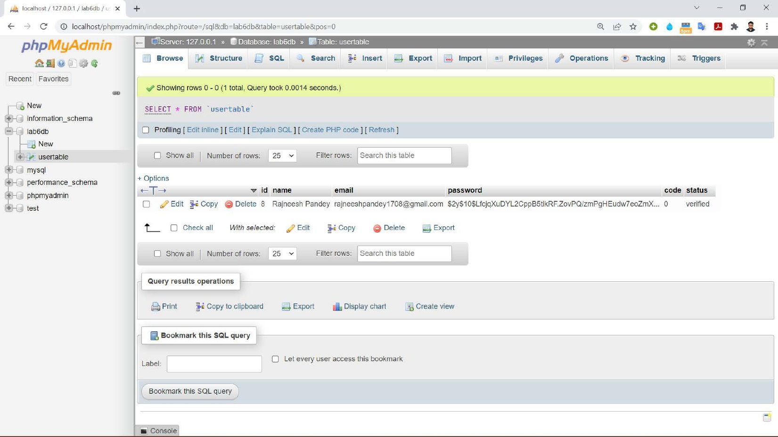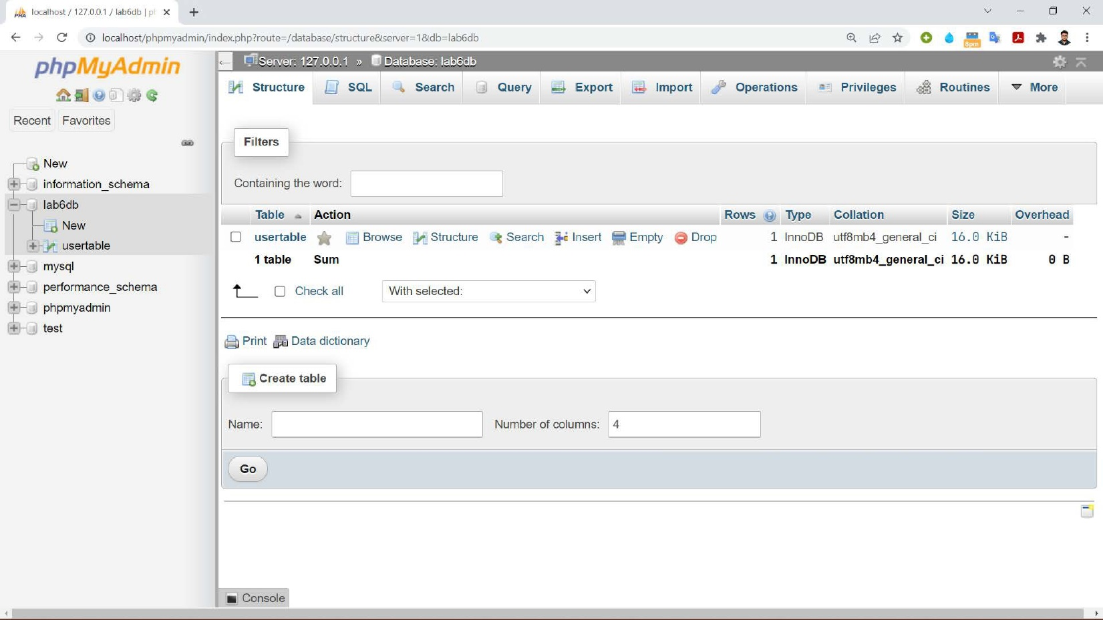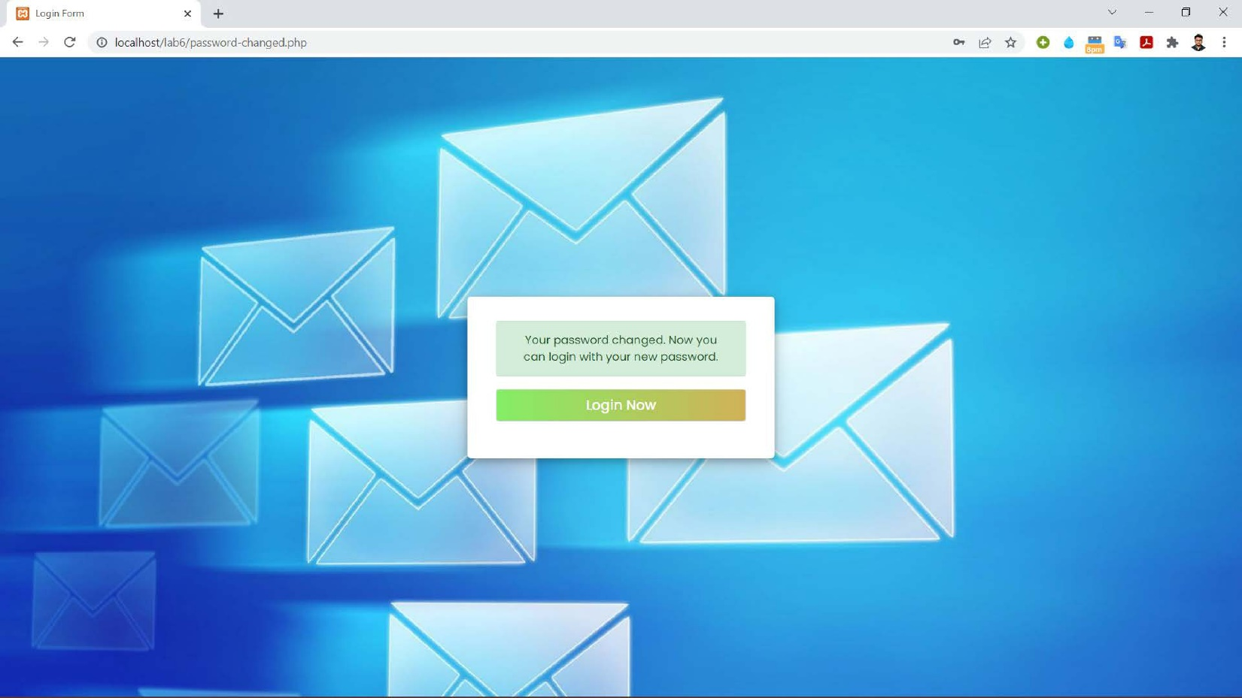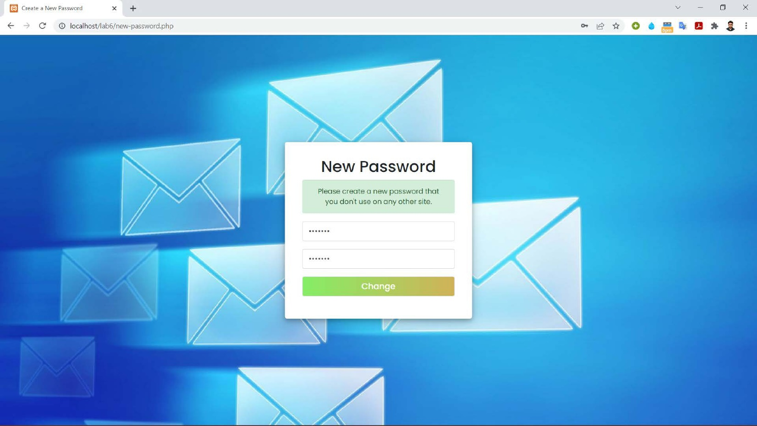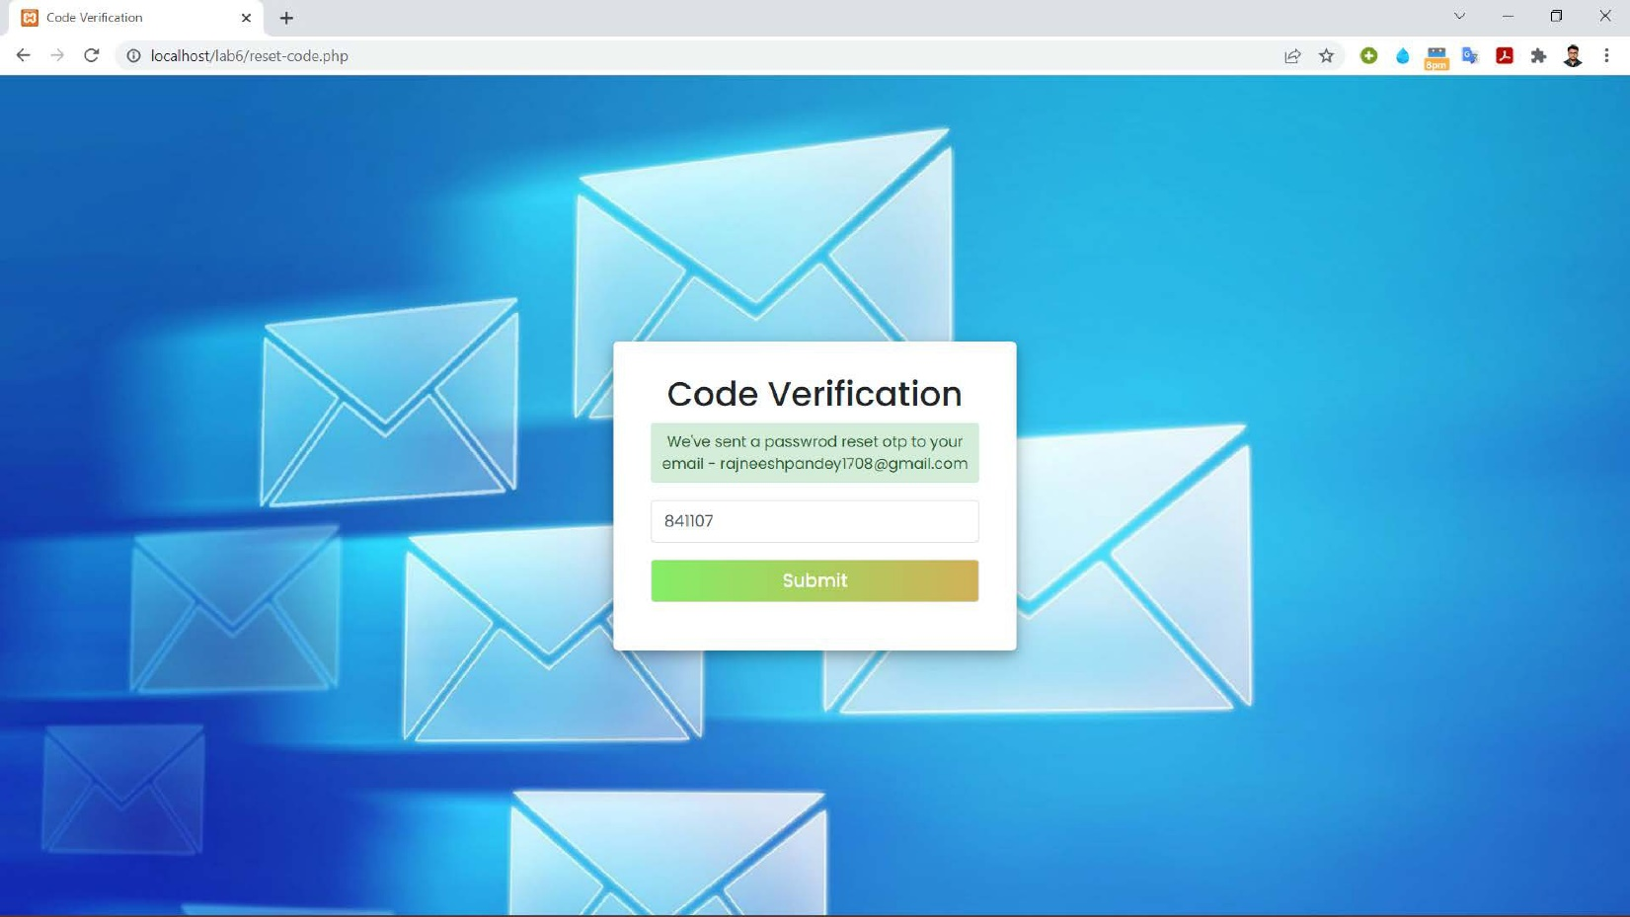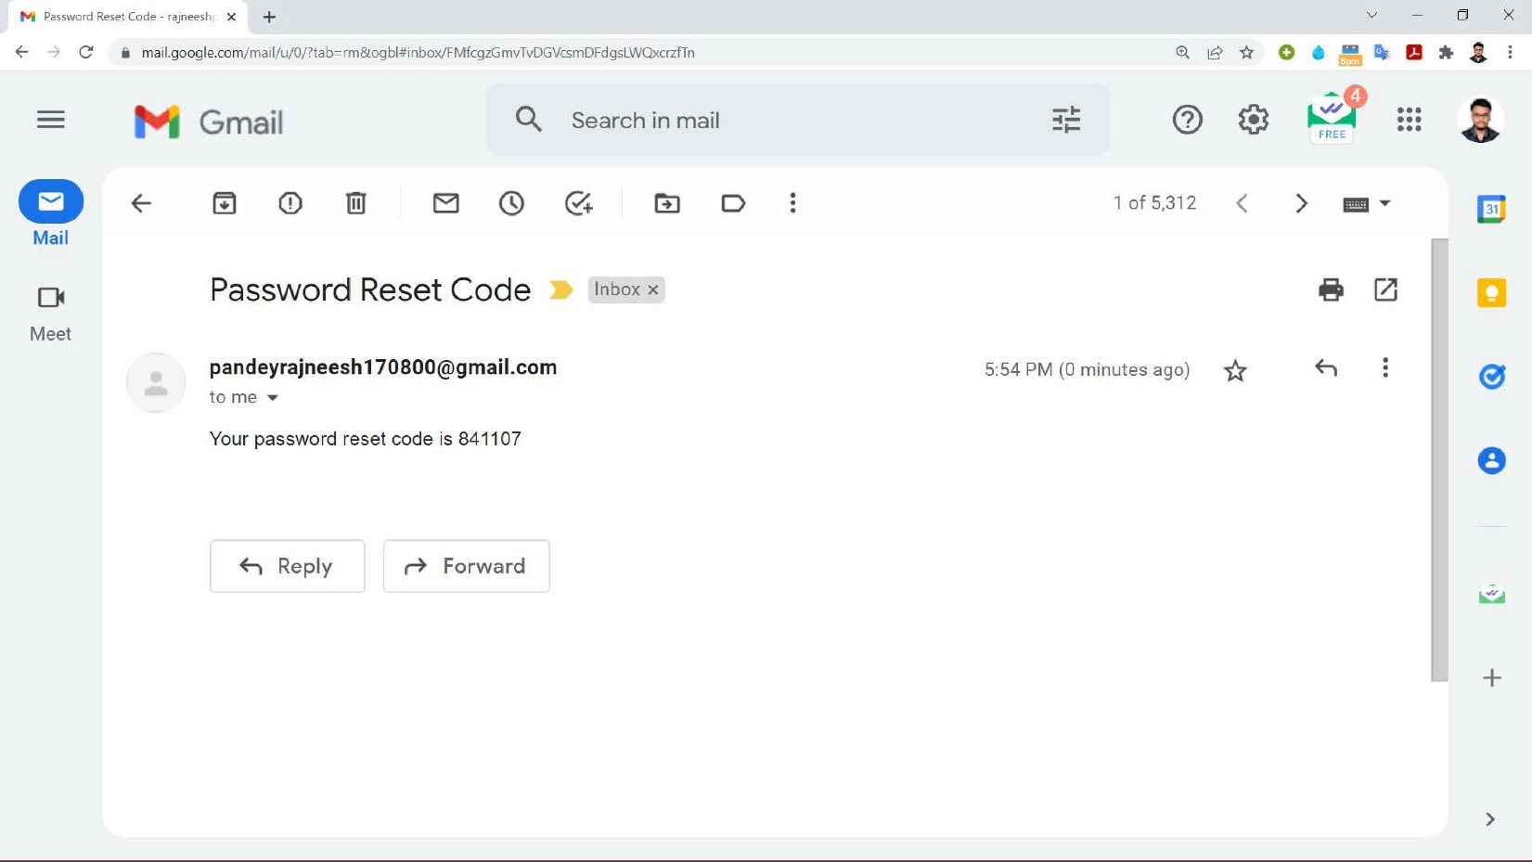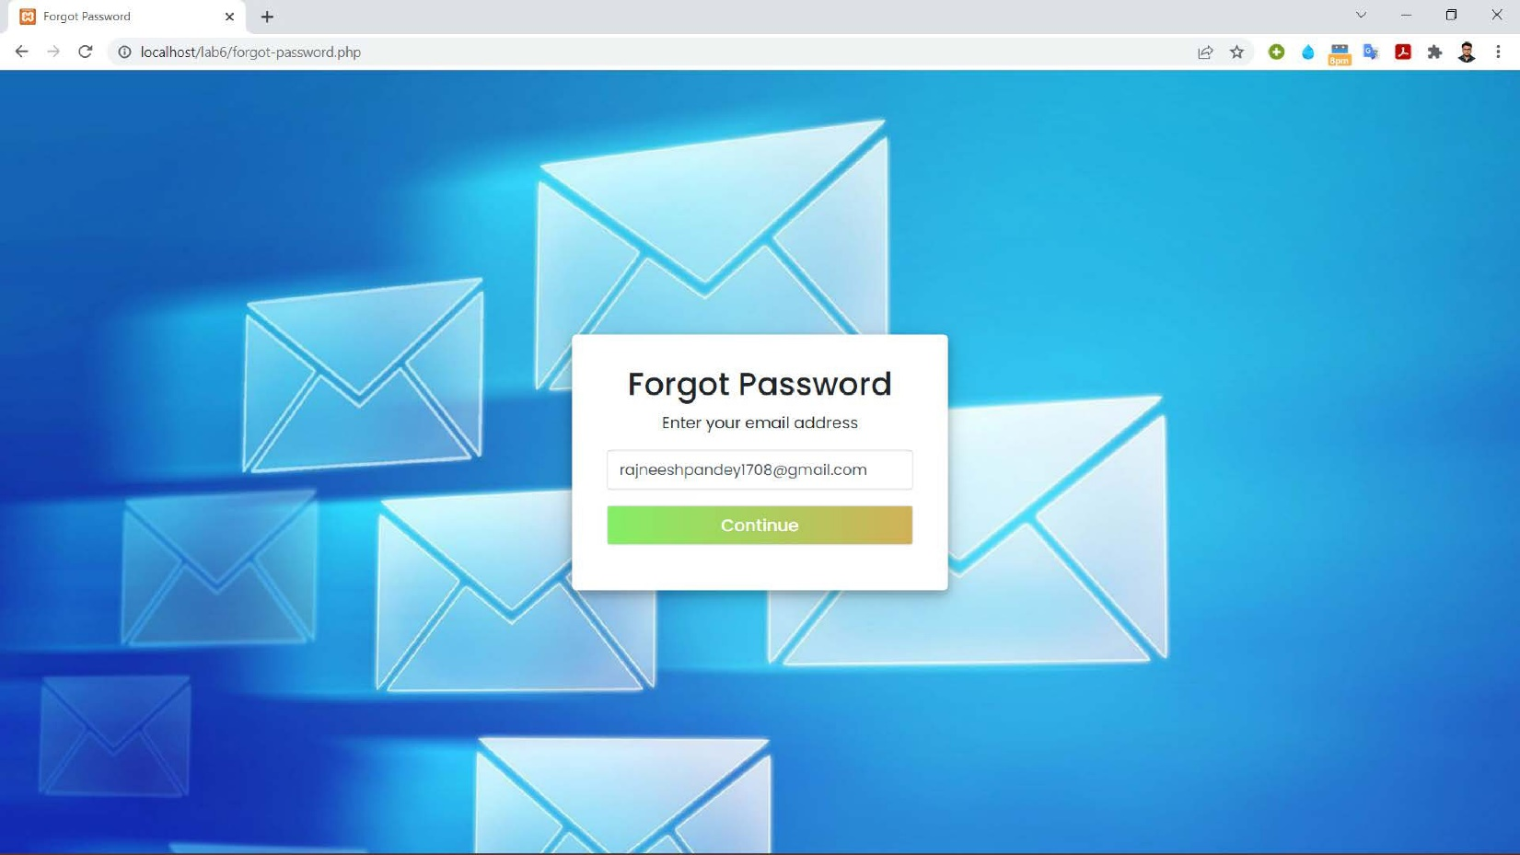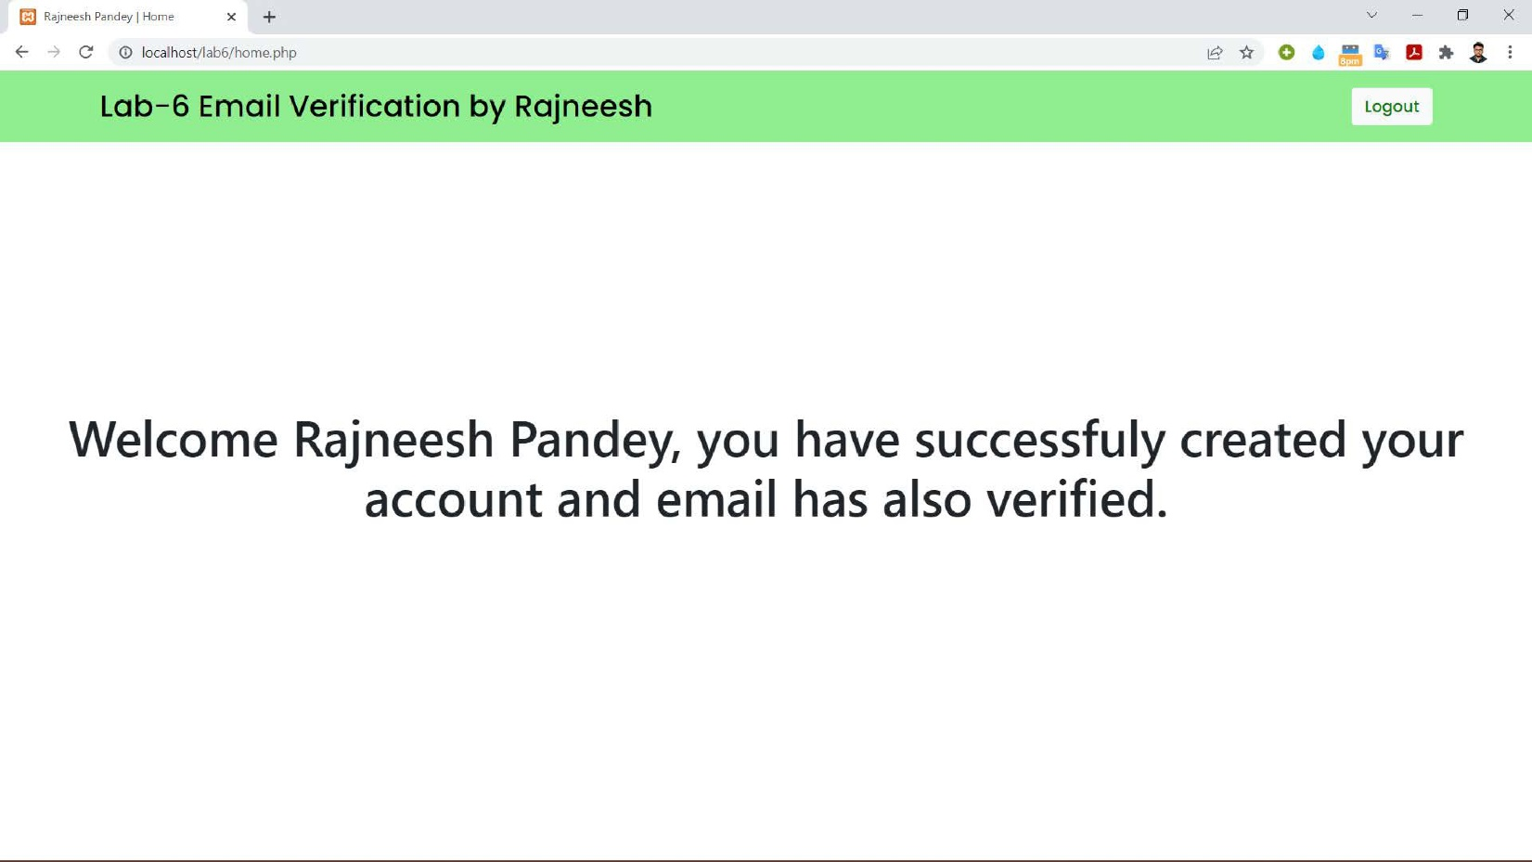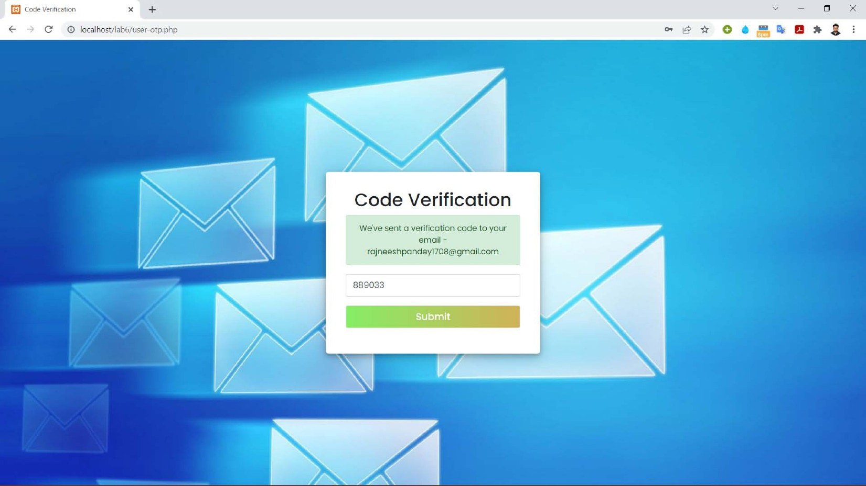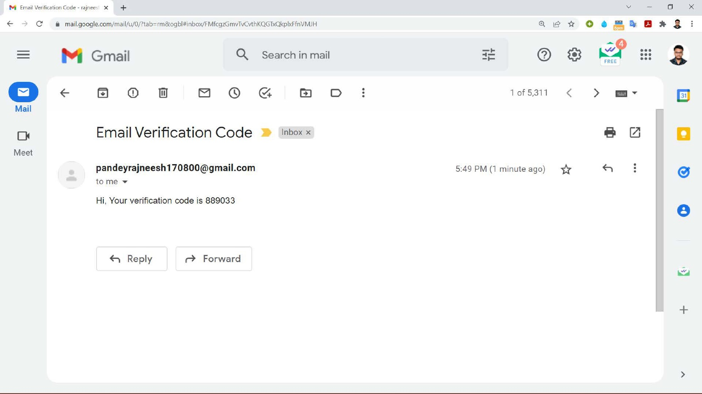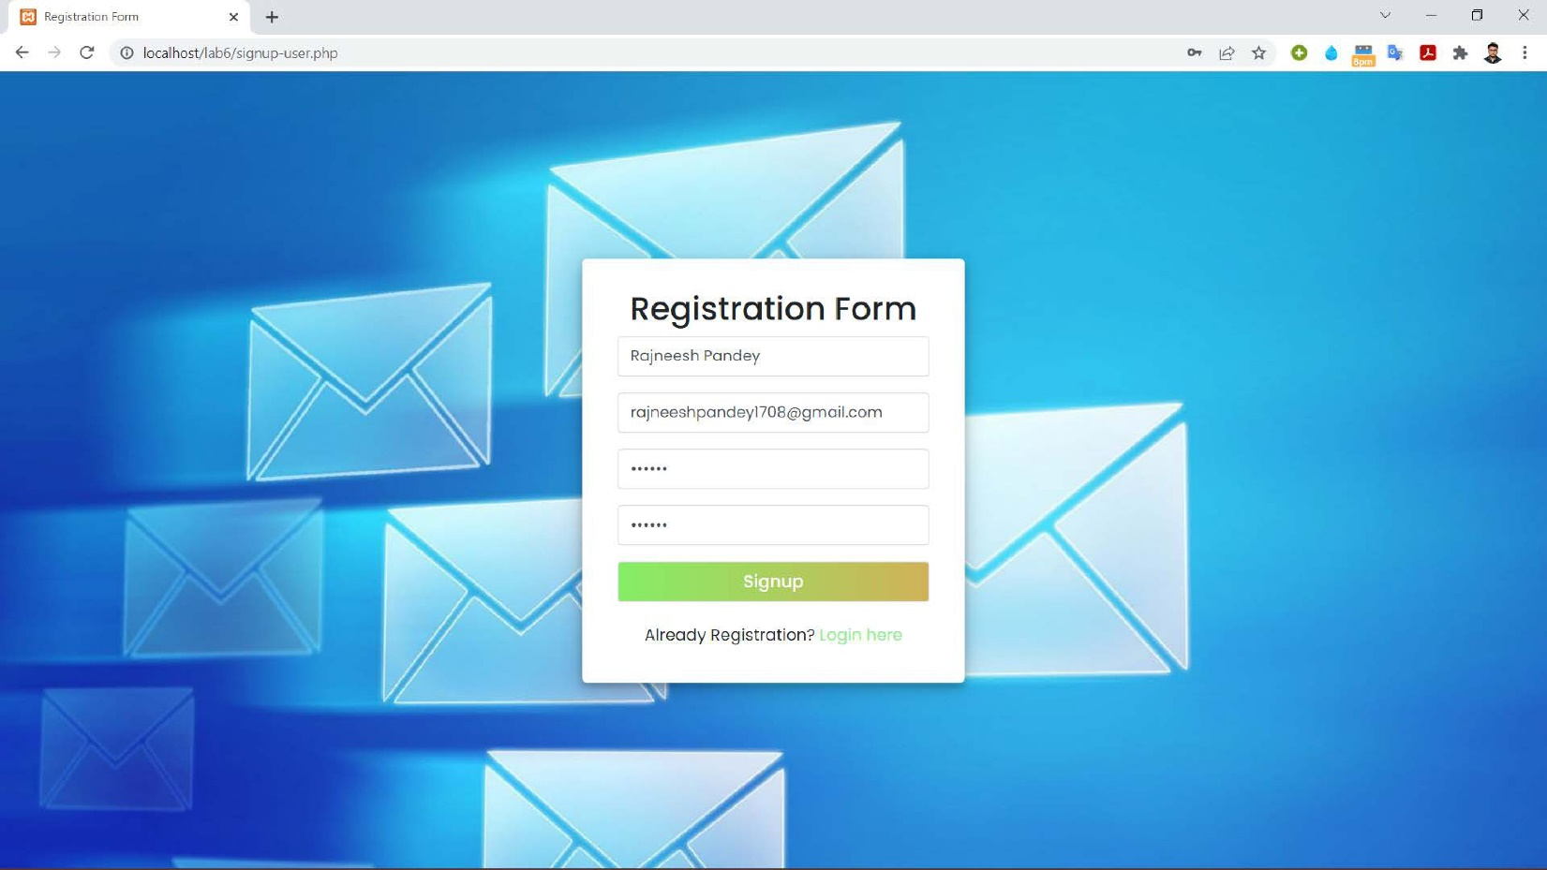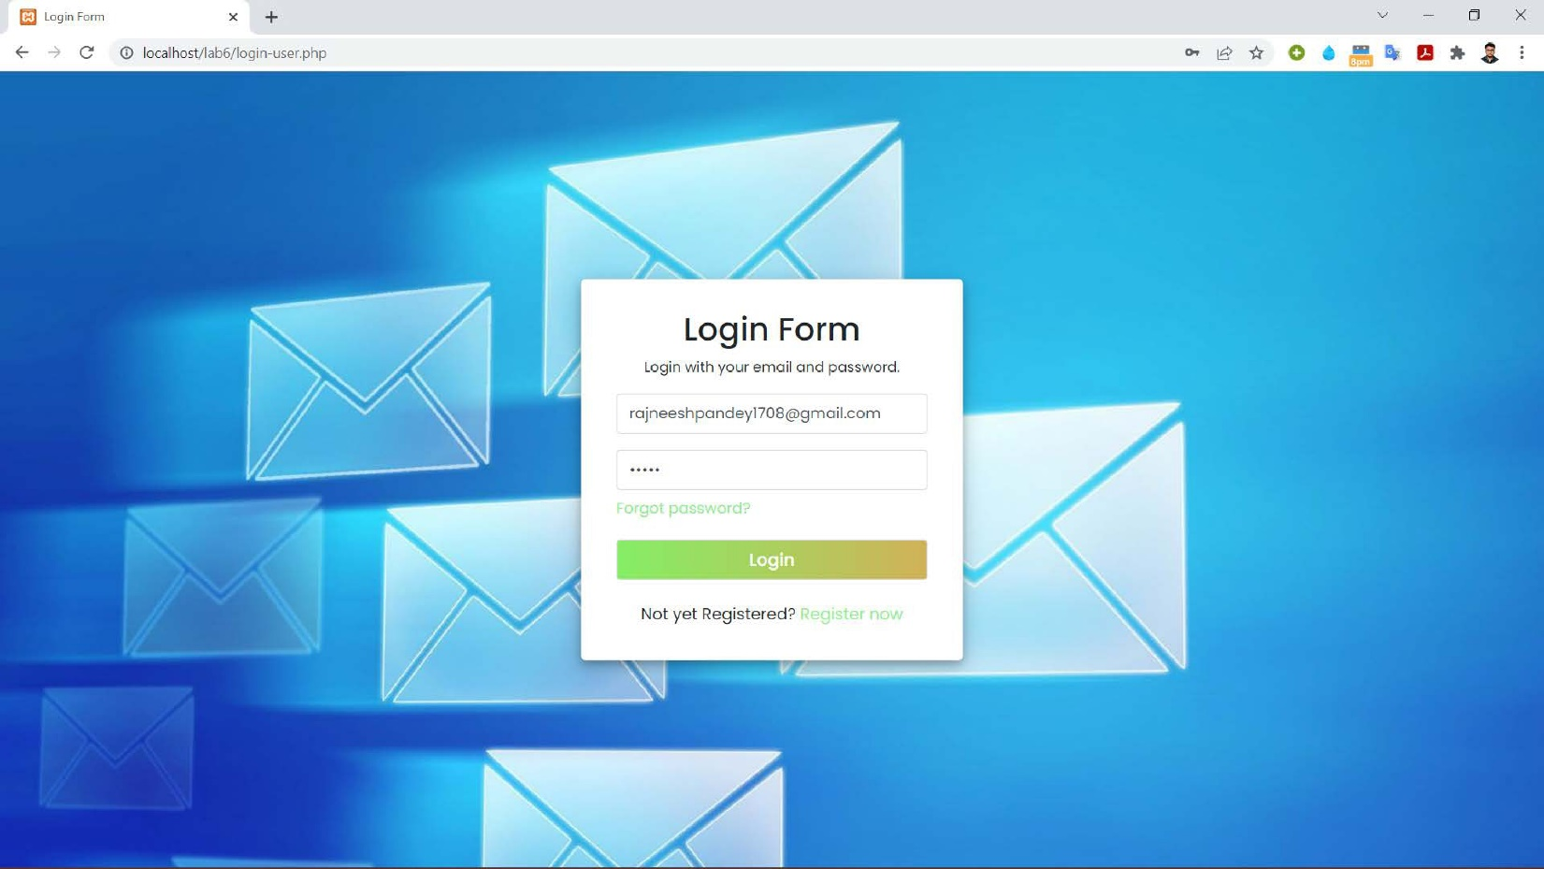

Date : 20/04/2022  **Lab 7**

**Problem statement**

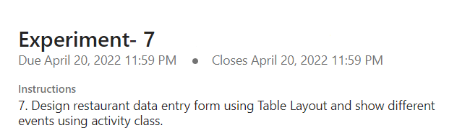

**Tools/Programming Languages Used**

Android Studio, XML Activity Class, Java, Kotlin

**Code Link**

<https://drive.google.com/drive/folders/1NjOTx3dwwy95V7BG5bMXD_2mxRBBKang?usp=sharing>

**Screenshots of Application**

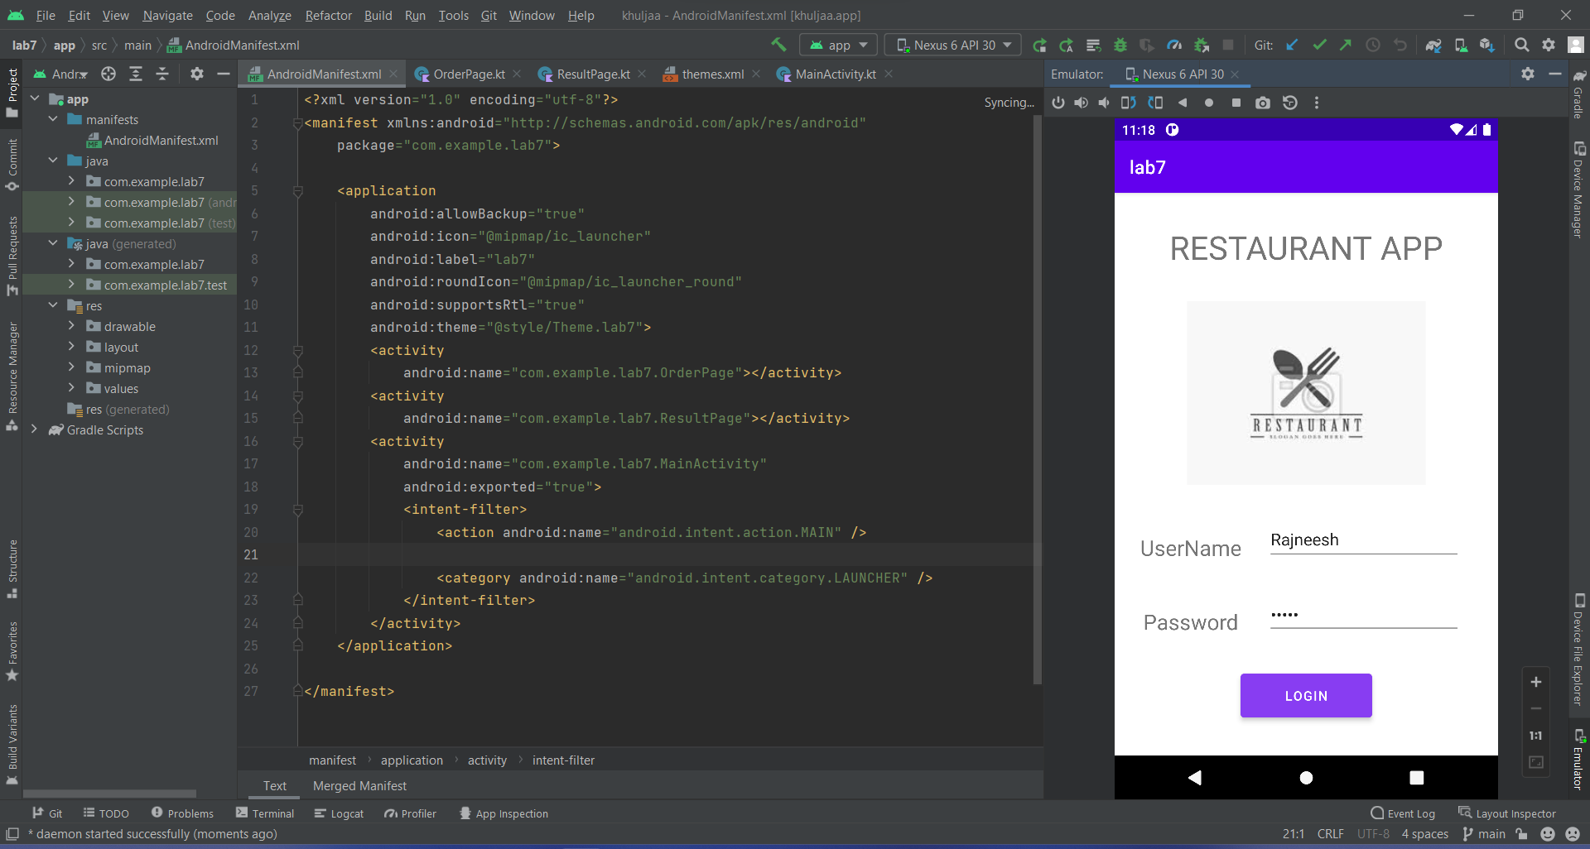

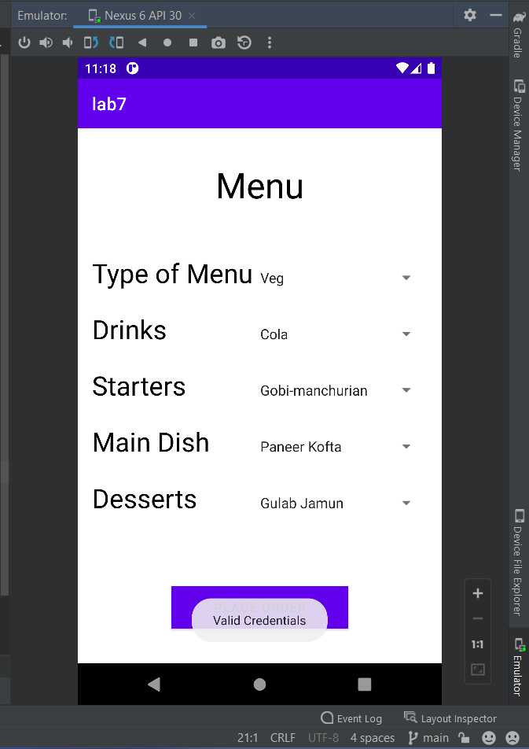 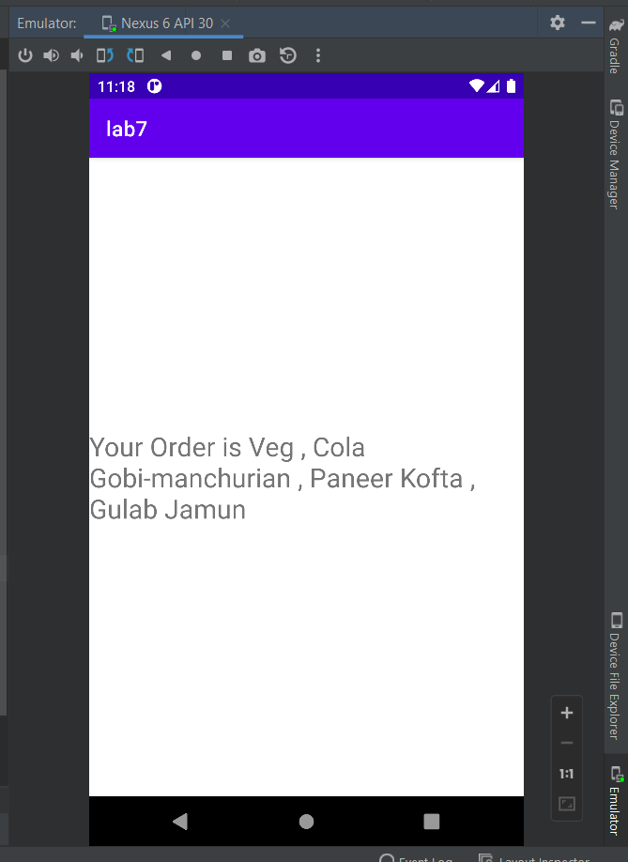

Date : 20/04/2022  **Lab 8**

**Problem statement**

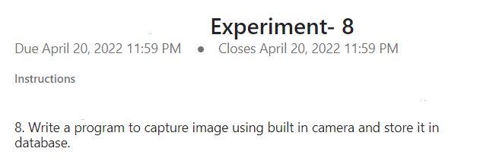

**Tools/Programming Languages Used**

Android Studio, XML Activity Class, Java, Kotlin, Local Storage (Database)

**Code Link**

<https://drive.google.com/drive/folders/1YITg_M056nYjtTVkKtmssYB2kse1p6LC?usp=sharing>

**Screenshots of Application**

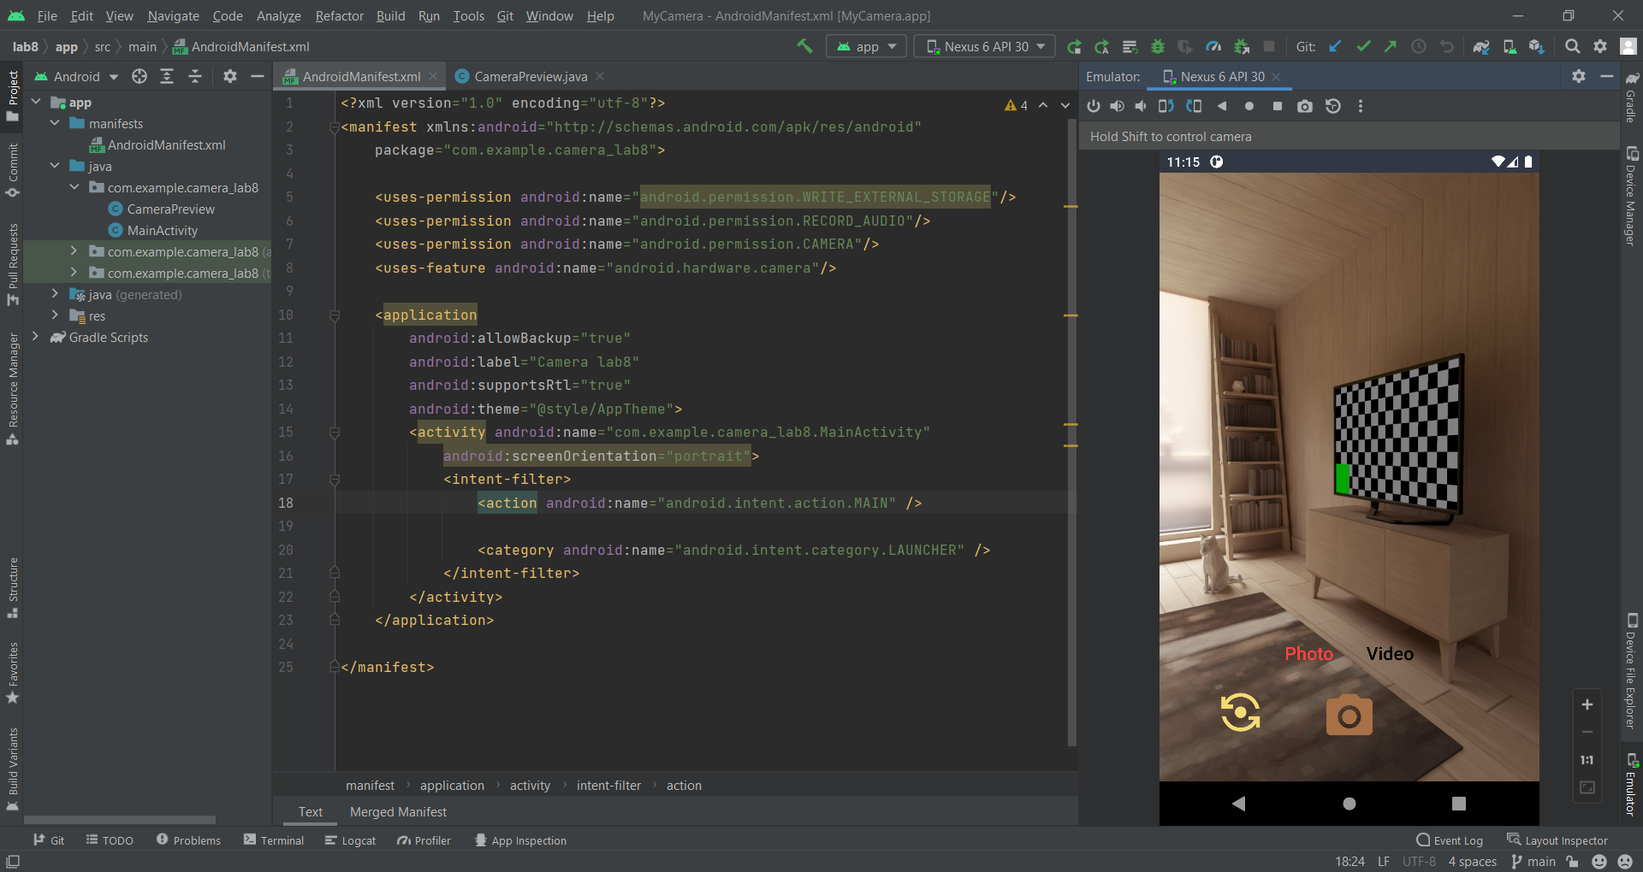

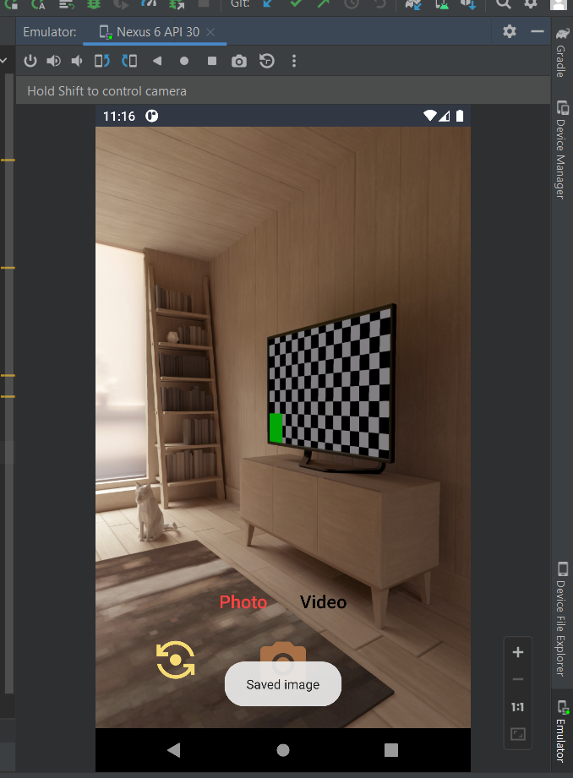 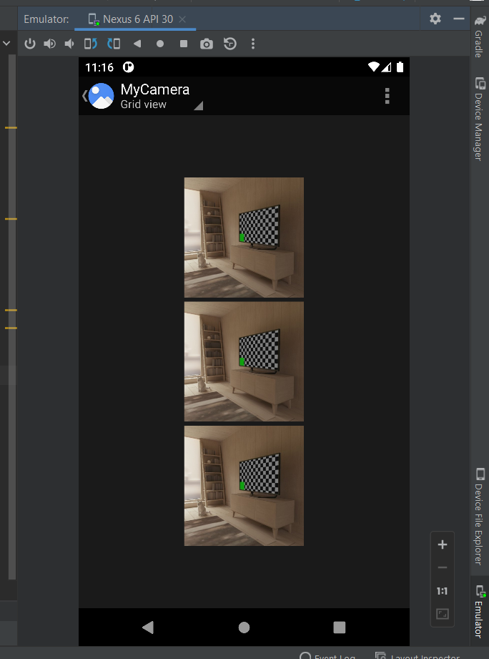

Date : 20/04/2022  **Lab 9**

**Problem statement**

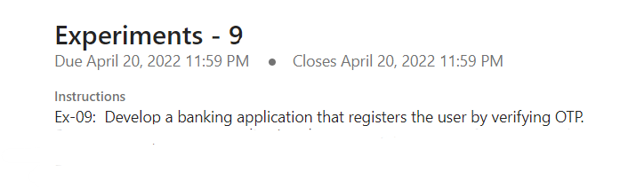

**Tools/Programming Languages Used**

Android Studio, XML Activity Class, Java, Kotlin, Firebase (Database)

**Code Link**

<https://drive.google.com/drive/folders/1wp3YxrJk0EsSloJDj1rRje91cCN3dGc3?usp=sharing>

**Screenshots of Application**

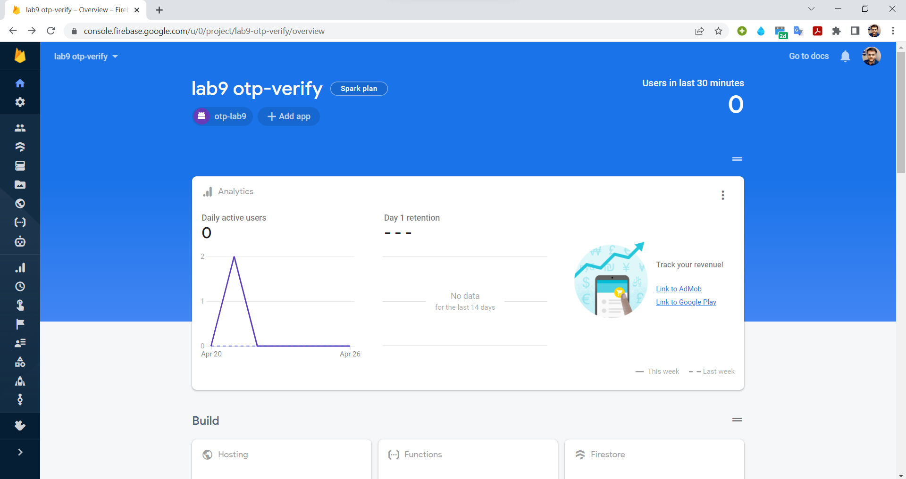

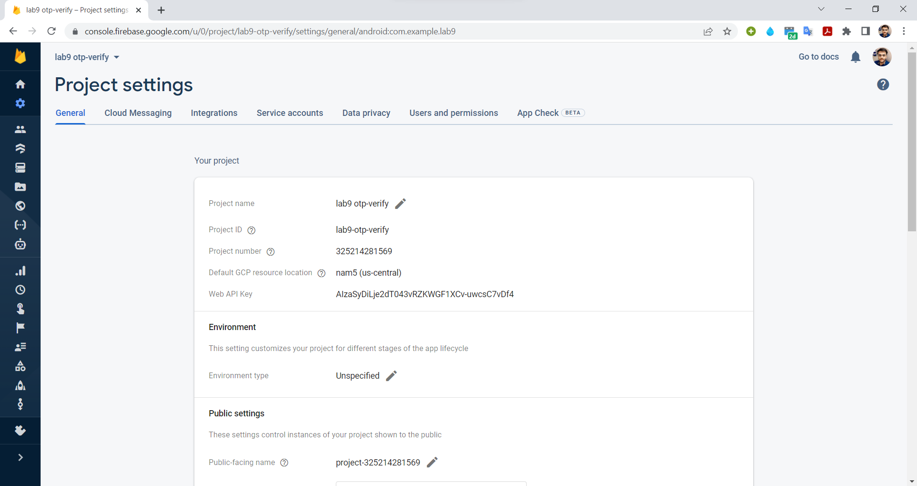

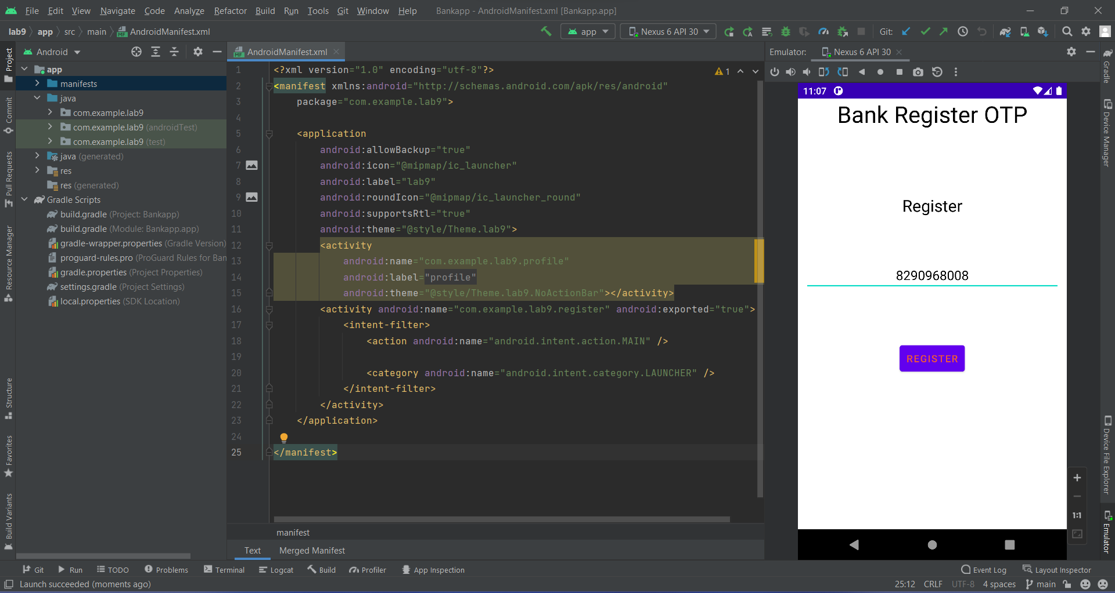

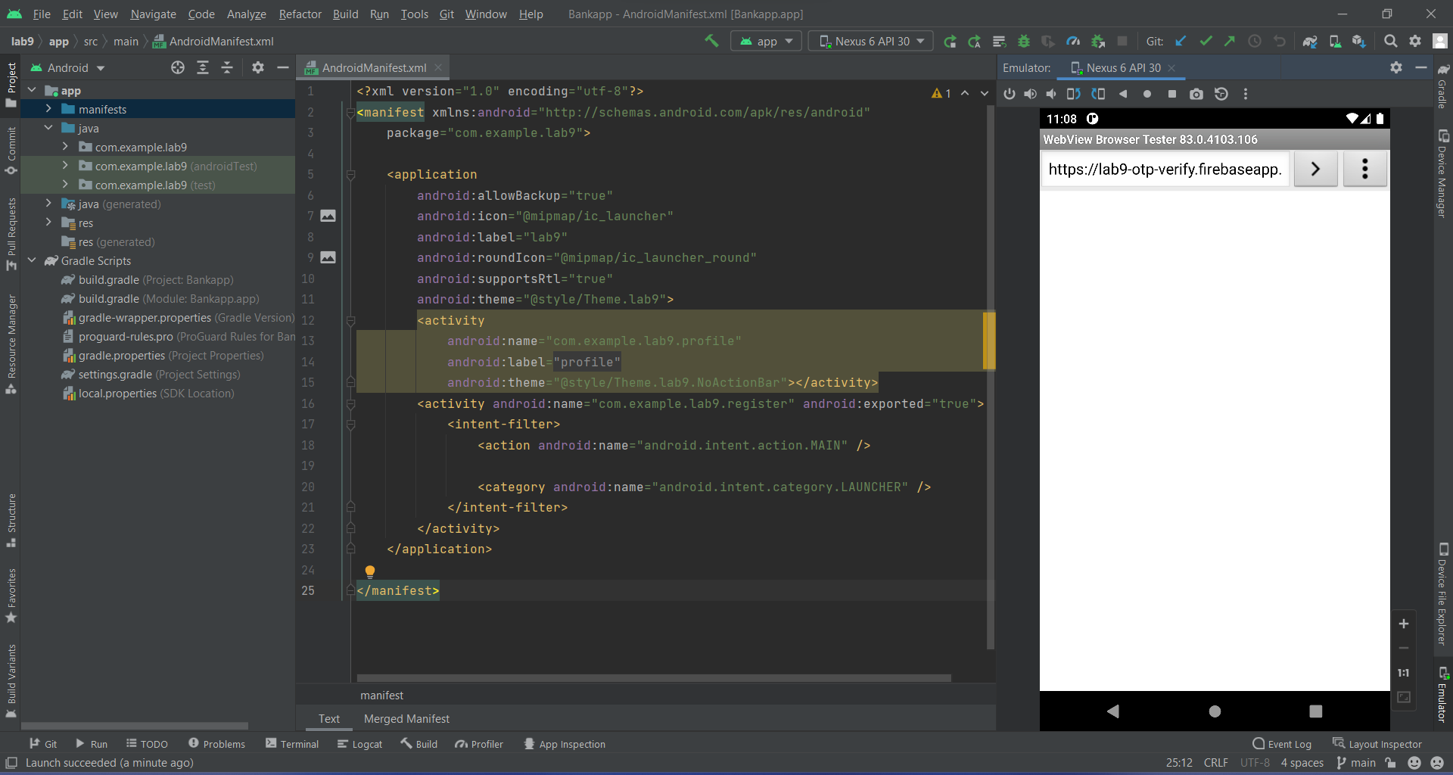

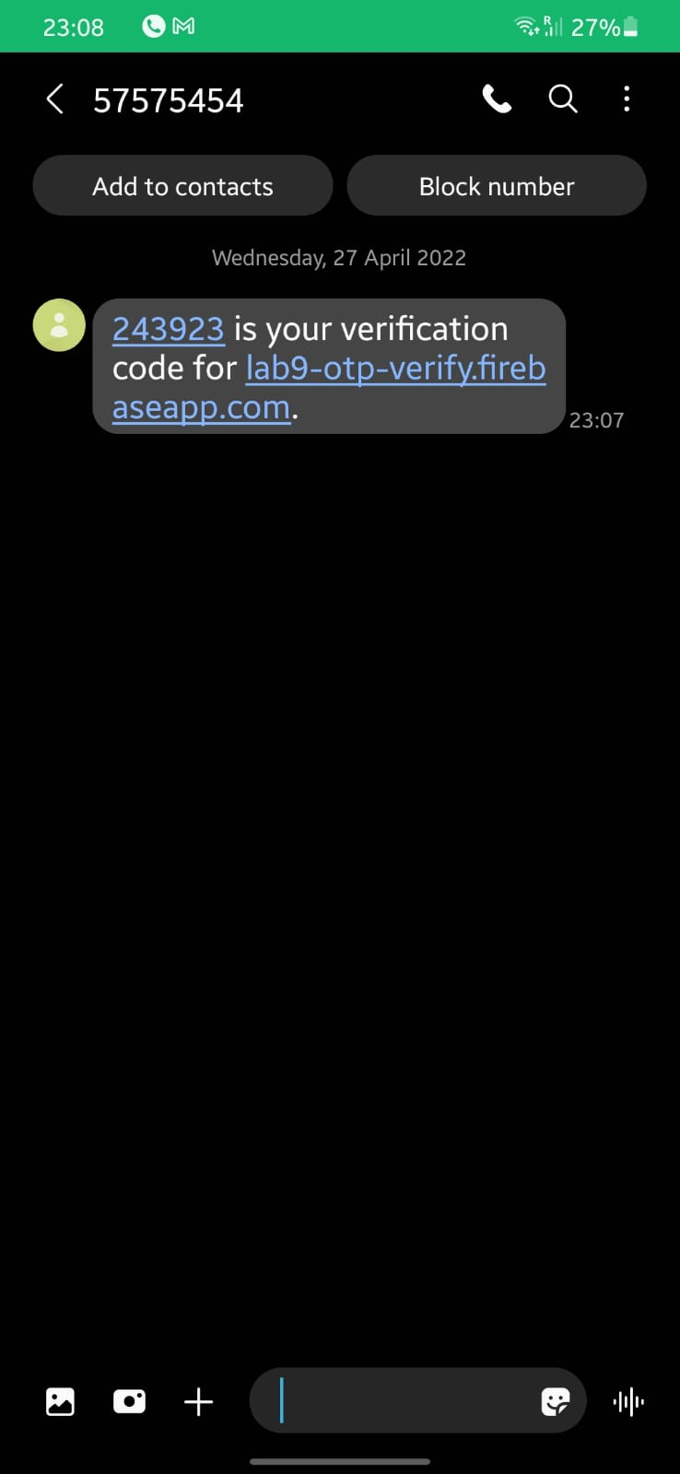 **OTP - Message on Phone**

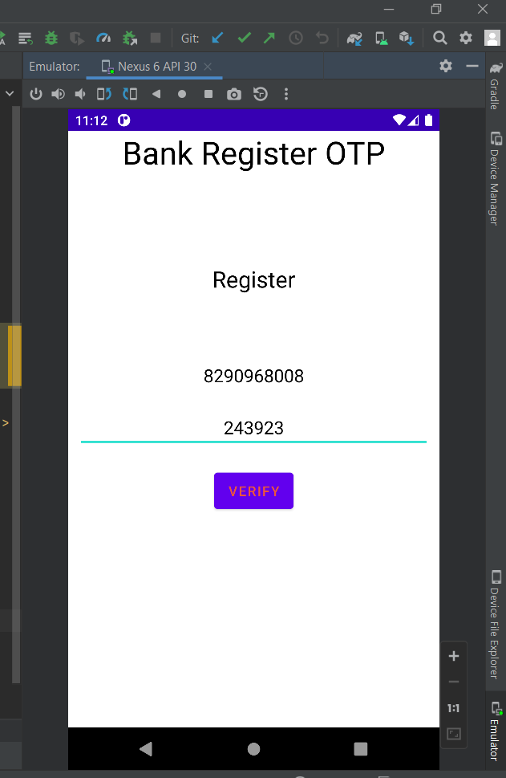 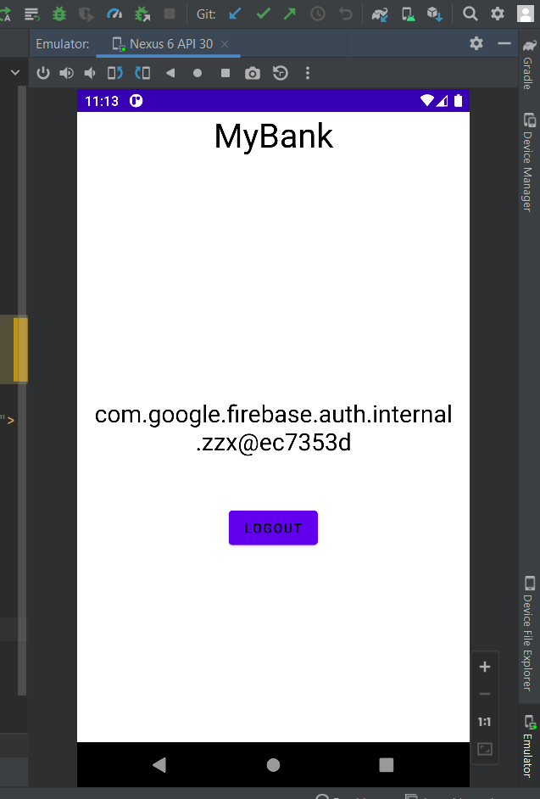

Date : 20/03/2022  **Lab 10**

**Problem statement**

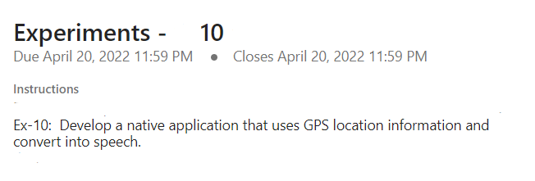

**Tools/Programming Languages Used**

Android Studio, XML Activity Class, Java, Kotlin, GPS Locator

**Code Link**

<https://drive.google.com/drive/folders/1uVPL9_coC7_M4m8RFfRJr_jnd22y4HvT?usp=sharing>

**Screenshots of Application**

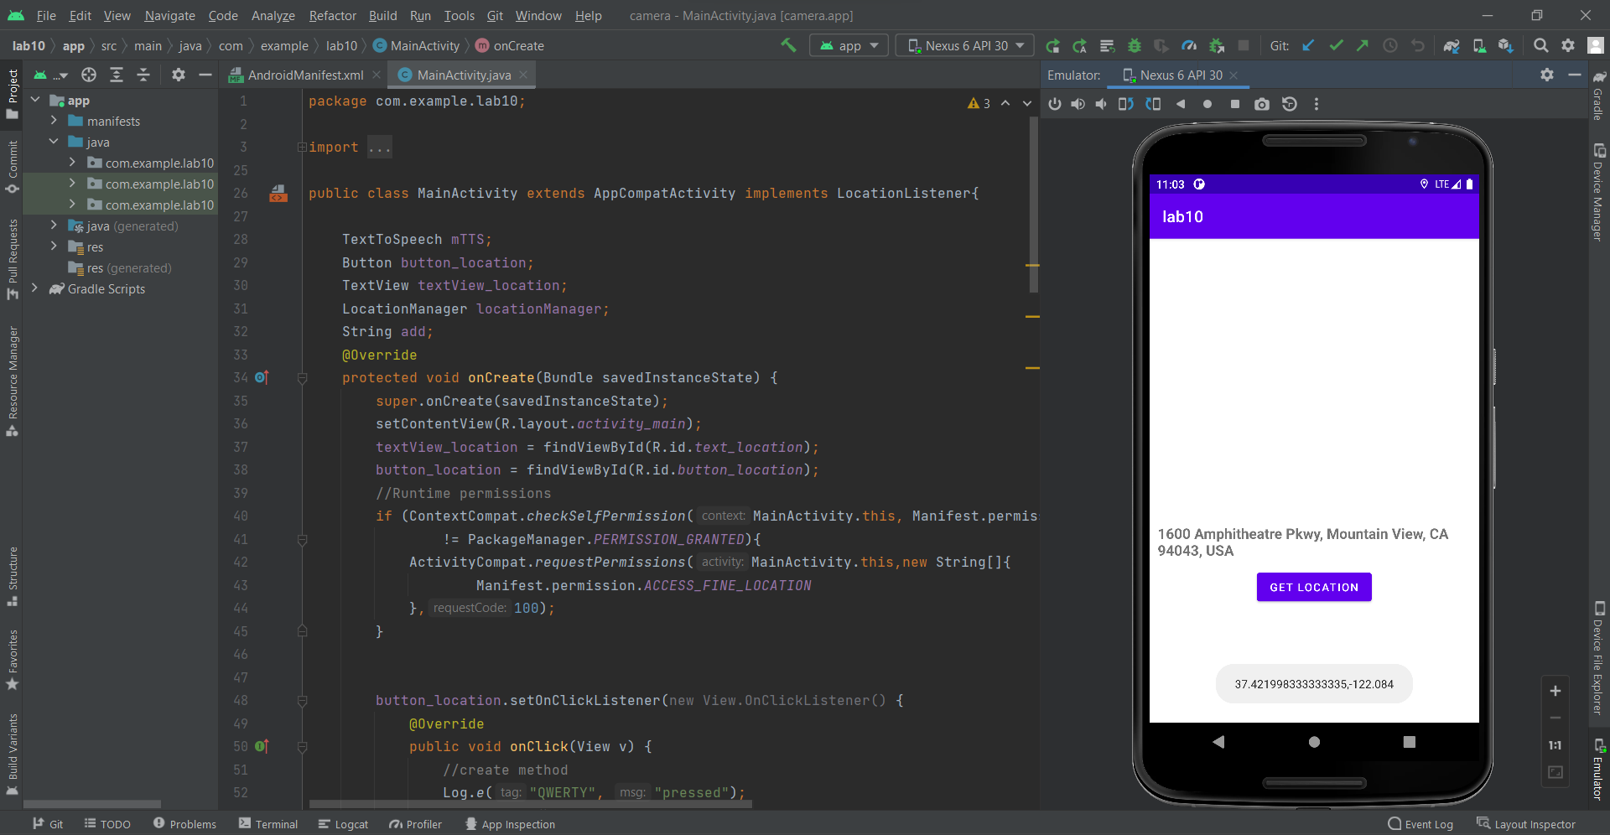

Date : 20/03/2022  **Lab 11**

**Problem statement**

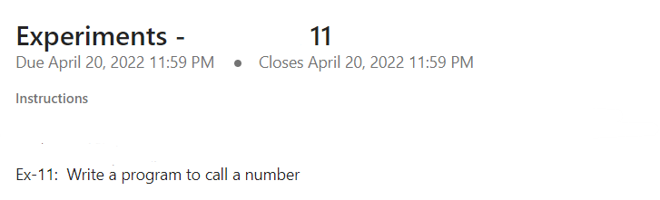

**Tools/Programming Languages Used**

Android Studio, XML Activity Class, Java, Kotlin

**Code Link**

<https://drive.google.com/drive/folders/1yiIlCcMpVyMUkduY0MvnYm8CYraQUHM3?usp=sharing>

**Screenshots of Application**

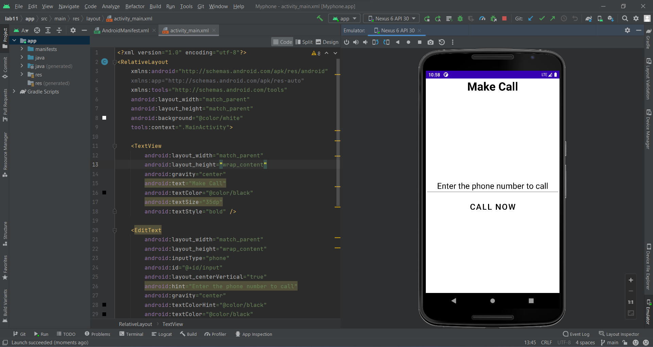

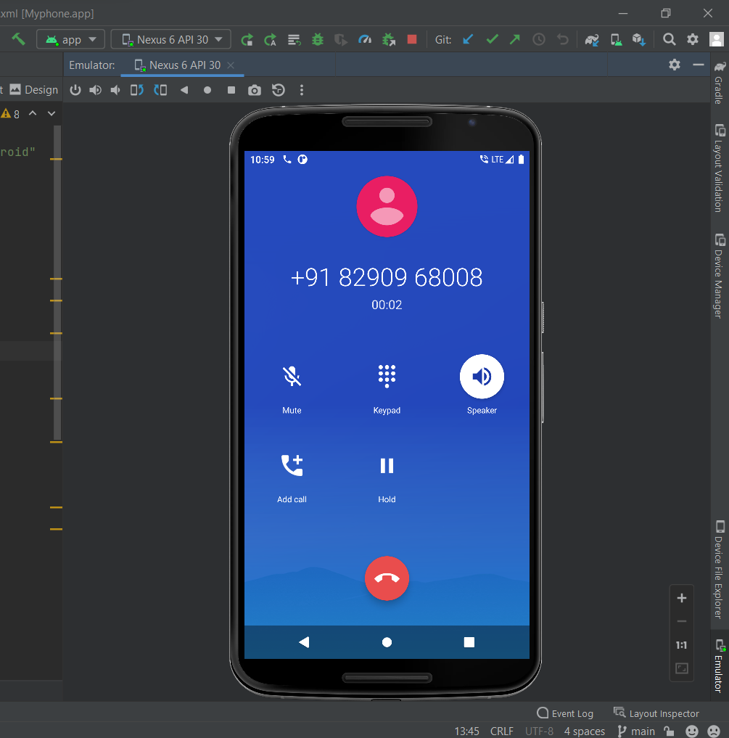

**Thankyou**